 | 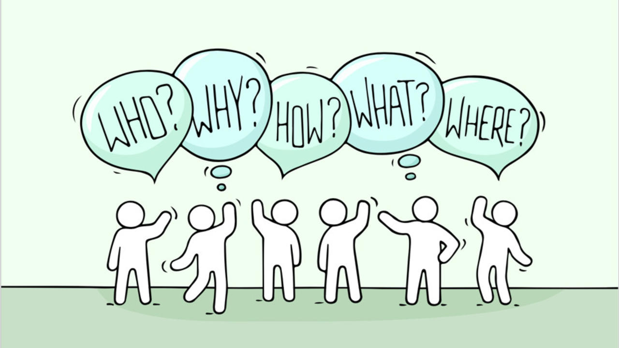 |  | 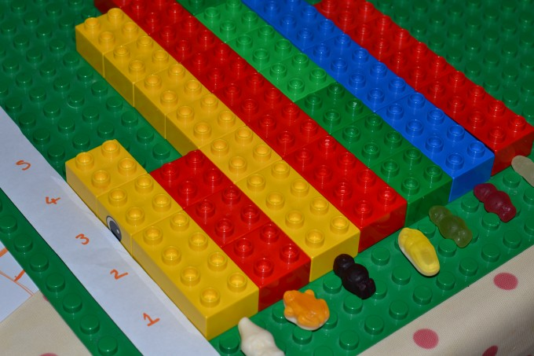 | 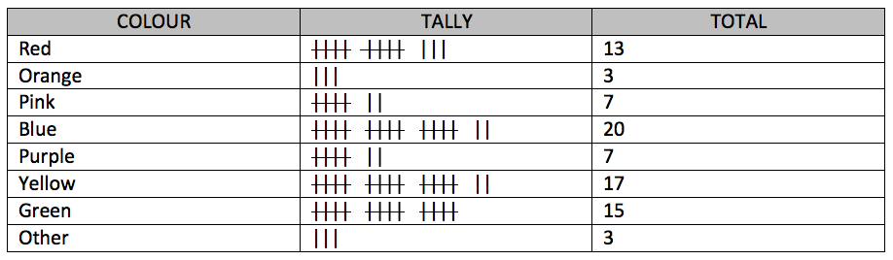
STEP | Problem | Plan | Data | Analysis
TASK | What do we want to know about our family?  Think of some questions you could ask about your family. Start by thinking about your question words (shown in the picture above) then think how these could help develop questions about your questions.  Here are some examples:  - How much TV do we watch?  - How much exercise do we do?  - What do we like to eat?  - Where do we like to visit? | What data do you need to answer your question?  Think about what data you need from each person in the family to be able to answer your question. This can be very simple by collecting one piece of data or you can collect several pieces of data.  For example if your question is what do we like to eat the simplest data to collect is the favourite meal of everyone in the family. Older children may want to record what the family eats at different meal times or where you eat meals.  You can use a mind-map like the one above to record your ideas about the questions you want to ask. | Collect your data  Now collect the data you need.  You can do this in lots of ways. Here are some examples.  - Use Lego/Duplo bricks to record exercise, each family member has a colour and each time they exercise they add a brick to their tower. You can have different numbers of bricks for duration or record different kinds of exercise in different towers  - Draw a table on a blackboard or piece of paper in the kitchen. Put your names on the left and the days of the week along the top, write down or draw what people eat each day. | What does our data tell us?  We want to look at our data and think about what we have found out. Steps here could include:  - Counting and adding up. How many times did we have chicken for tea  - Finding Patterns. Did we always watch cartoons on a Friday?  - Understanding size. Did someone exercise more than someone else?
FINISH | Pick one question for your family infographic and write it down. | Write down the information you want to collect. | Record your data. | Talk about what you have discovered. You can write down your favourite discoveries.

If you require this document in an alternative format, such as large print or a coloured background, please contact Claire Sowton, data.schools@ed.ac.uk or Moray House School of Education and Sport, St John’s Land, Holyrood Road, Edinburgh, EH8 8AQ

