North American Zoo and Aquarium Species

What are the most common creatures in zoos and aquariums?

Here are the 15 species that have the highest number recorded in North American zoos and aquariums:

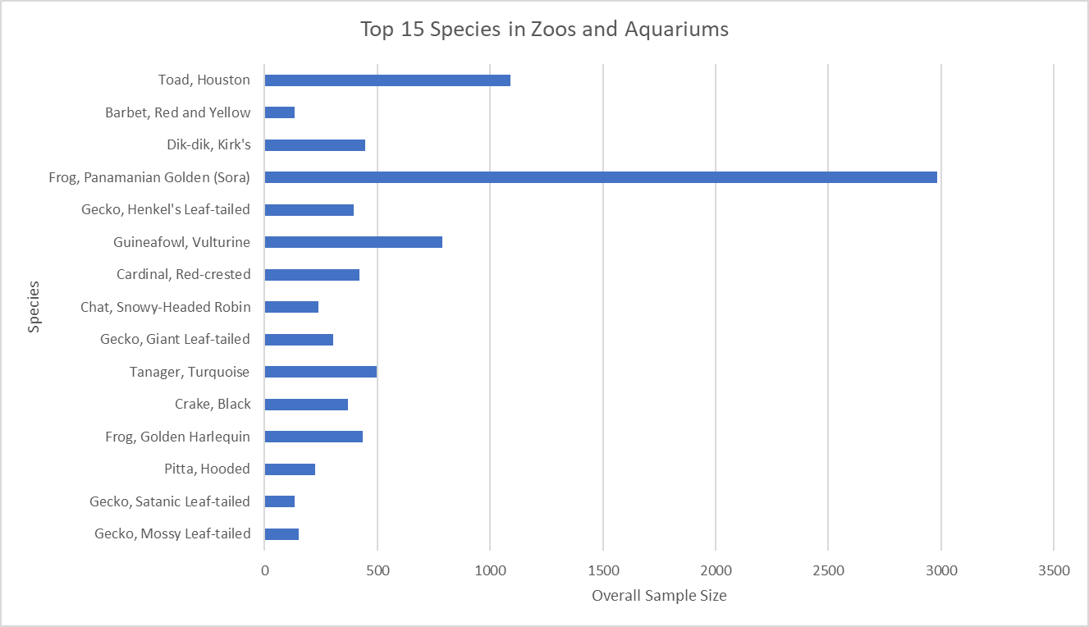
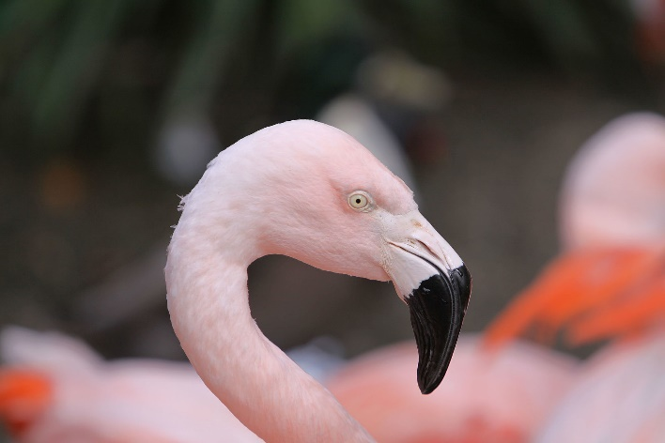
There have been 3406 Chilean Flamingos in zoos and aquariums in North America.
They live on average 27.8 years.
The males live 30 years on average and the females live 26.6 years.

Image by Elrond, CC BY-SA 4.0, https://commons.wikimedia.org/w/index.php?curid=45467804

How long do creatures live on average in zoos and aquariums?

The average life expectancy of Mammals (mammalia) has been 13.8 years, and only 5.4 years for amphibians (amphibia).
There are three types of Wallaby species in the dataset. On average they live for 5.5 years, but the females live 5.7 years.
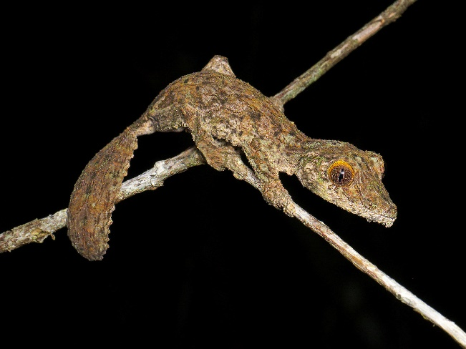
The shortest average life expectancy is for the Mossy Leaf-tailed Gecko, which lives 2.4 years on average. They are from Madagascar and their primary threat is the destruction of their habitat and deforestation. (https://en.wikipedia.org/wiki/Uroplatus_sikorae)
Image by Frank Vassen from Brussels, Belgium - Mossy leaf-tailed gecko (Uroplatus sikorae), Vohimana reserve, Madagascar, CC BY 2.0, https://commons.wikimedia.org/w/index.php?curid=39798550

What’s the greatest difference between Males and Females life expectancy?

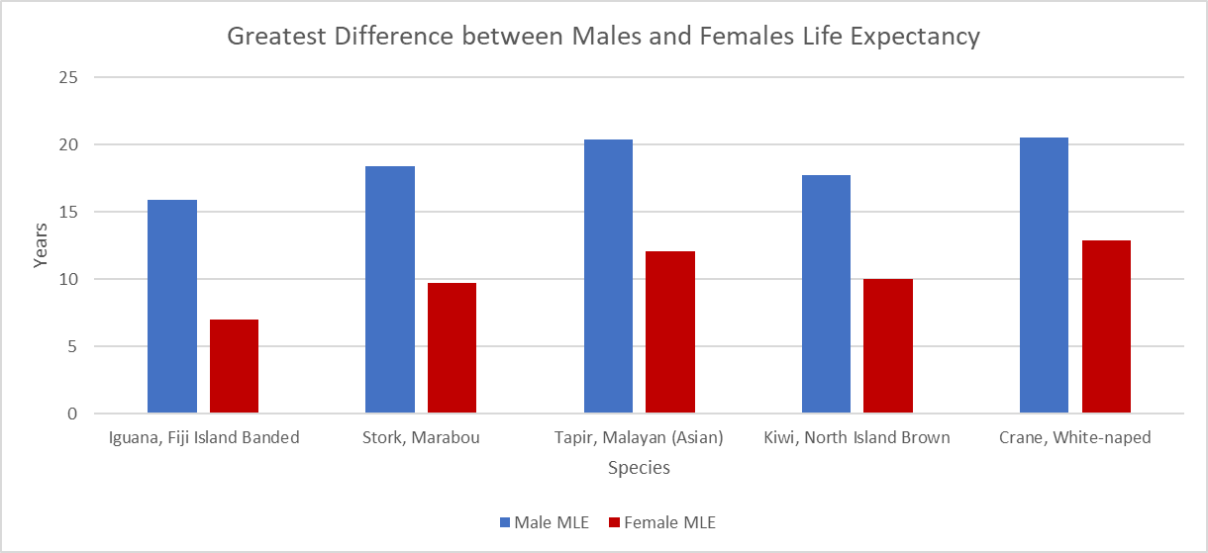
The male Fiji Island Banded Iguanas live on average almost 16 years, but the females only live around 7 years. That’s almost 9 years difference.

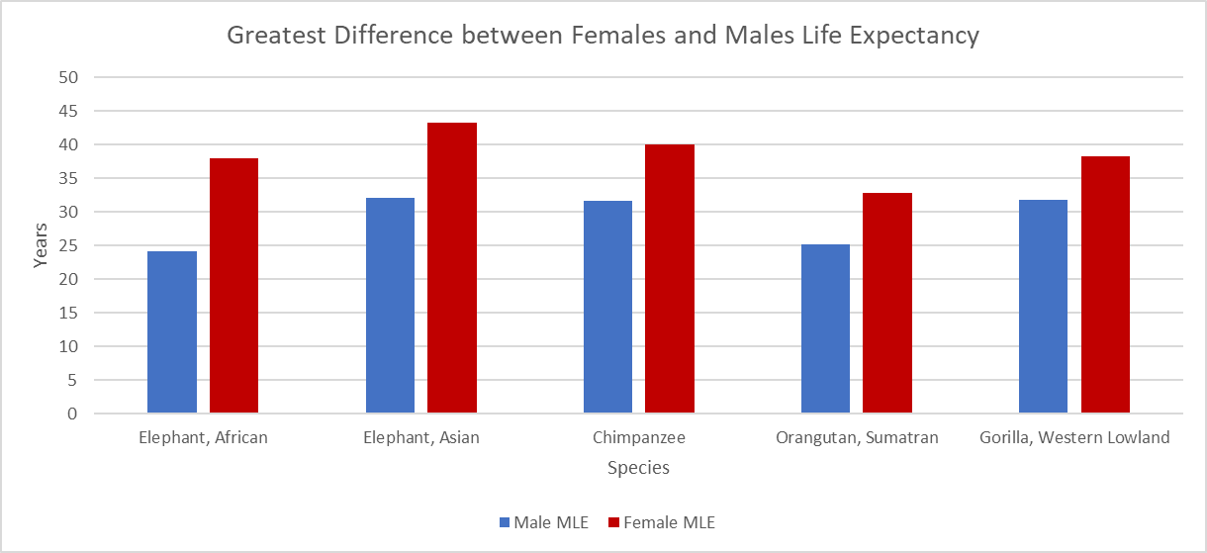
Female African Elephants live about 38 years but the males only live around 24 years on average. That’s a difference of almost 14 years!

