Microbit Monsters!
We’re going to make pet Microbit monsters!

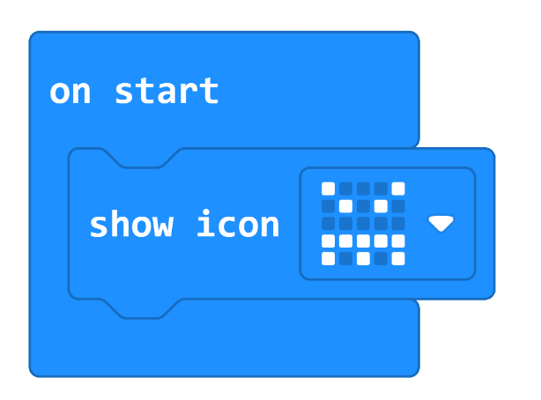
Make a face!

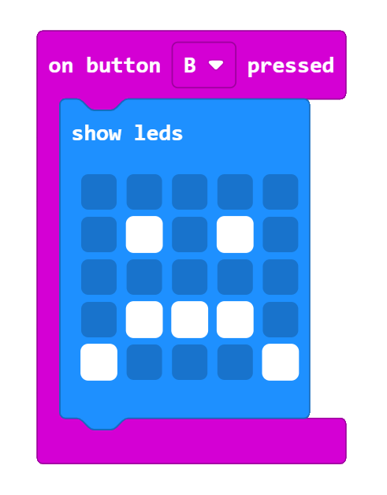
More moods!

Make your monster sing!

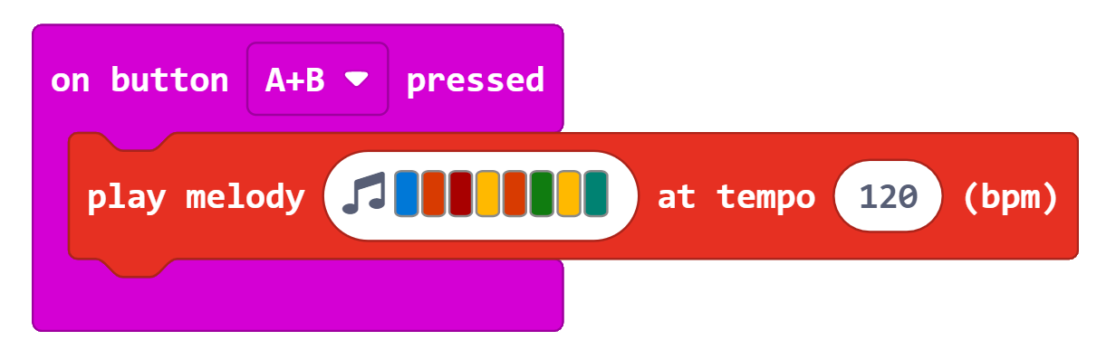

Make your monster body

Design a body for your Microbit Monster,
then cut it out and fold it

Animations!
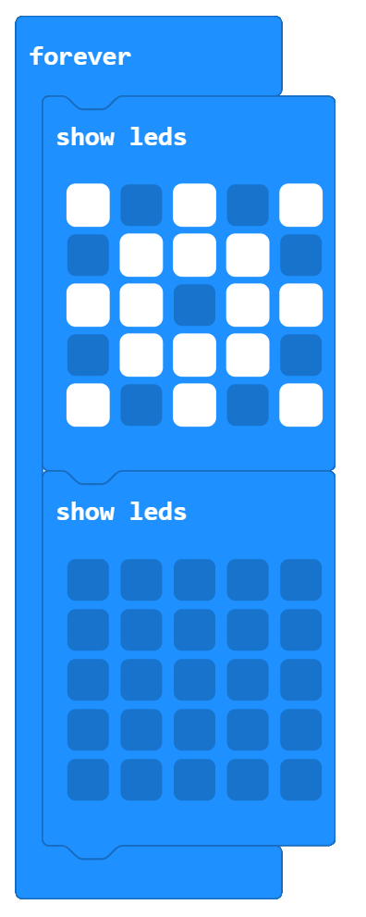
Make a flashing star
It doesn’t have to be a star. You can make a flashing heart, face or duck!

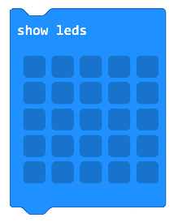
Make an
animation
You can use lots of show leds blocks to make an animation

Plan your animation
Colour boxes to show the lights that will turn on

