Data Monsters!
We’re going to make pet monsters that will help us by telling us the temperature.

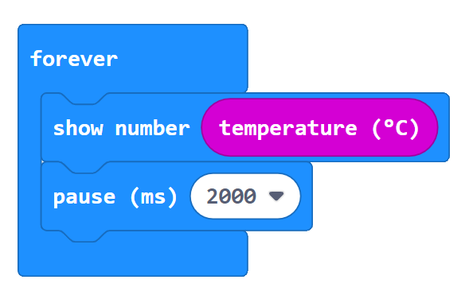
Make a thermometer
There’s 1000 milliseconds (ms) in a second.
How many seconds will this Micro:bit wait?

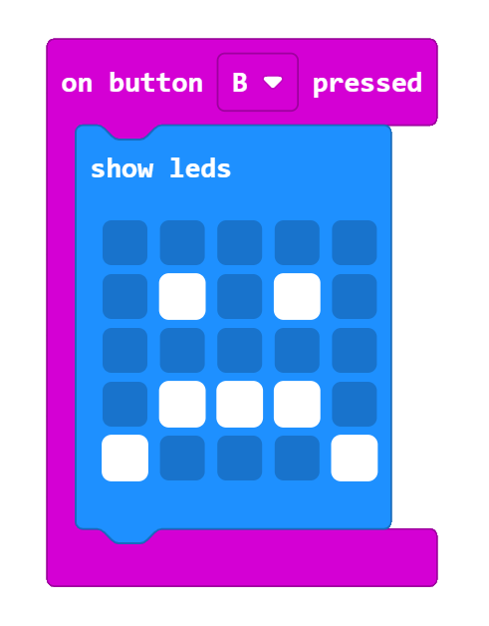
Make a face!
You can use the ‘show icon’ block or, if you want to design it yourself, the ‘show leds’ block
EXTRA: Choose what LEDs turn on when you press the buttons?

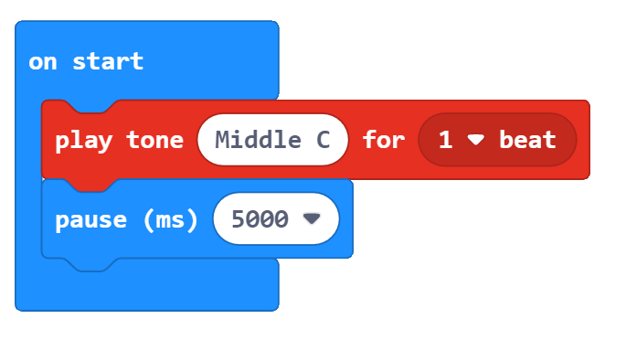
Make a reminder noise
Can you make the monster wait 30 minutes instead of 5 seconds?
EXTRA: Can you make it play a tune instead?
Our monsters can make a noise to remind us to look at the temperature!

Make your monster a body
Design a body for your Micro:bit Monster, then cut it out and fold it
Put your Monster to work!
Listen out for your Monster. When it beeps, look at the
temperature and mark it on the graph.

