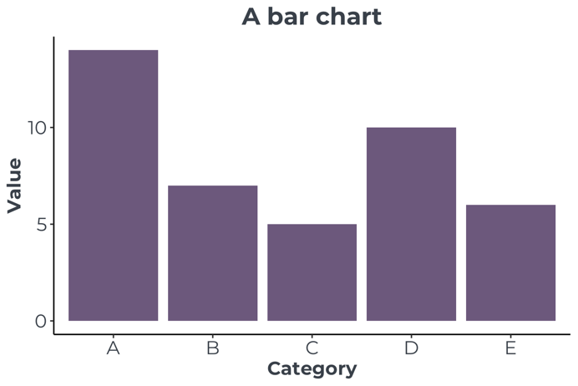

Bar charts use rectangular bars to compare values in different categories.

The bars normally show the counts or sizes of categorical data.

Since there is no connection between the bars, they are normally shown not touching.
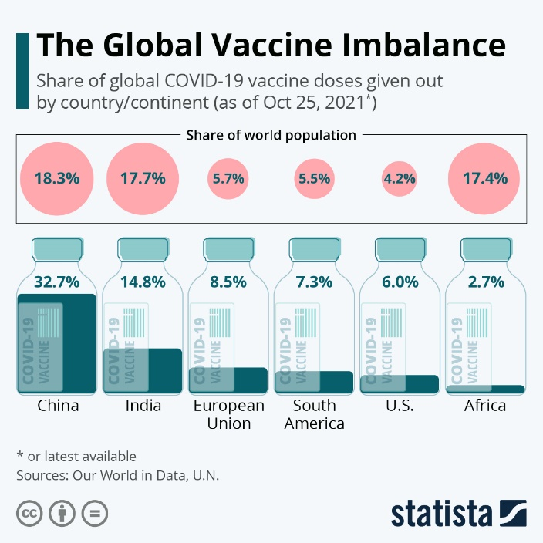
https://www.statista.com/chart/26055/share-of-vaccine-doses-covid-19-share-of-world-population/

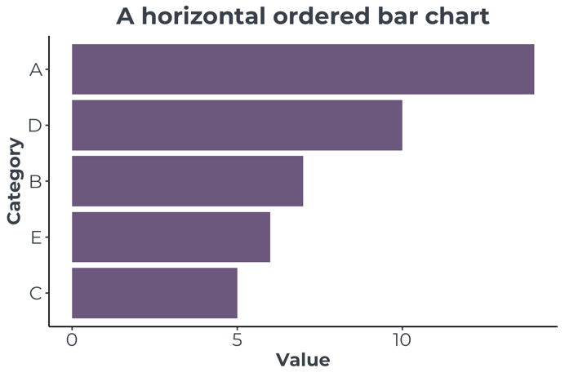

A horizontal bar graph is often a good option when there are many categories, or the category labels are long.

It is also possible to reorder the bars, which makes it easier to see the smallest and largest categories.

These can also be highlighted by using different colours.

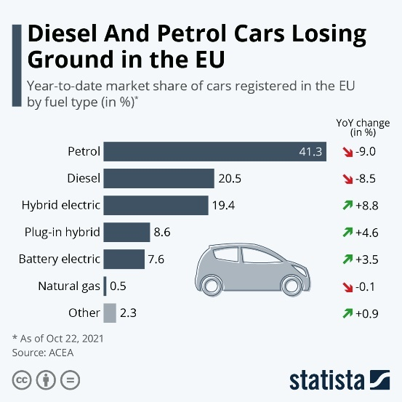

https://www.statista.com/chart/26037/market-share-of-cars-registered-in-the-eu-by-fuel-type/

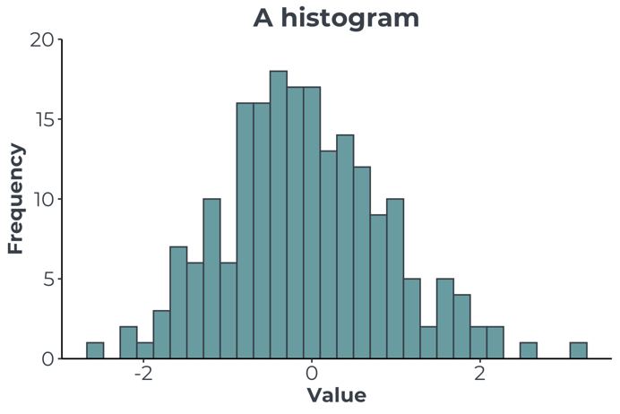
A histogram might look very similar to a bar chart, but it is fundamentally different since it is plotting numerical rather than categorical data.

Histograms are used to examine the distribution of a numerical variable. The x-axis contains the value of the numerical variable, which is then binned into ranges, and the frequency of points in the range is displayed on the y-axis.

The bars on a histogram should always be displayed as touching, since the variable is continuous. If there are gaps between the bars, then that implies missing data in that range.

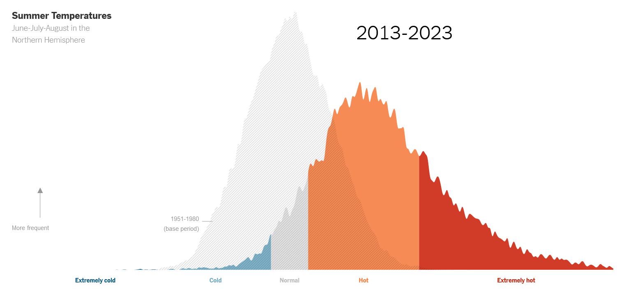
https://www.nytimes.com/interactive/2023/climate/extreme-summer-heat.html
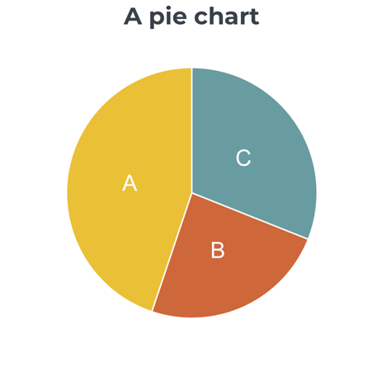

Pie charts show the proportion of a whole. The total of the pie must add up to 100%.

Although popular, pie charts are often not the best choice of graph to use, since it is much more difficult for human brains to estimate relative angles, or segments of the chart.

When they are used with more than two or three segments it is very difficult to pick out slivers or compare relative segment sizes.

A bar chart can always be used in place of a pie chart and is much clearer to read.

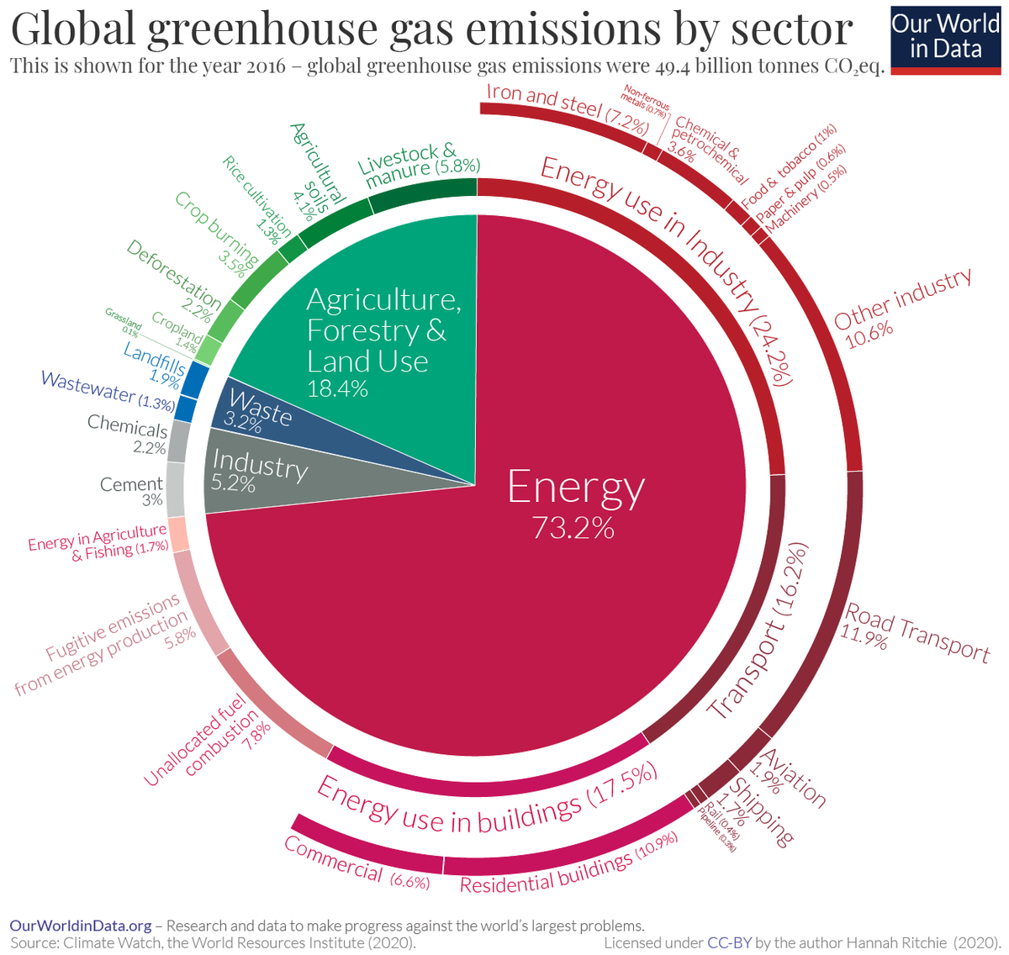
https://www.visualcapitalist.com/a-global-breakdown-of-greenhouse-gas-emissions-by-sector/

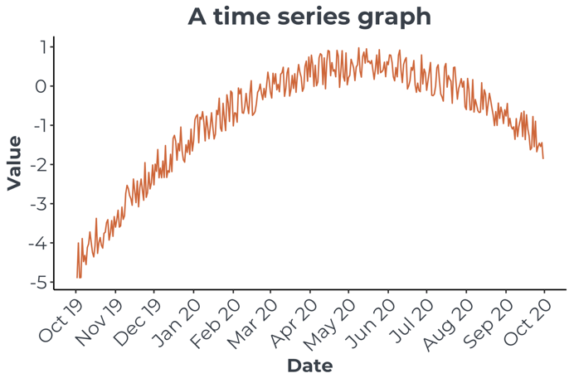

A time series graph is a special type of line graph, with time on the x-axis and regular repeated measurements of a variable on the y-axis.

Time series are good for spotting long term trends like a regular seasonal variation.

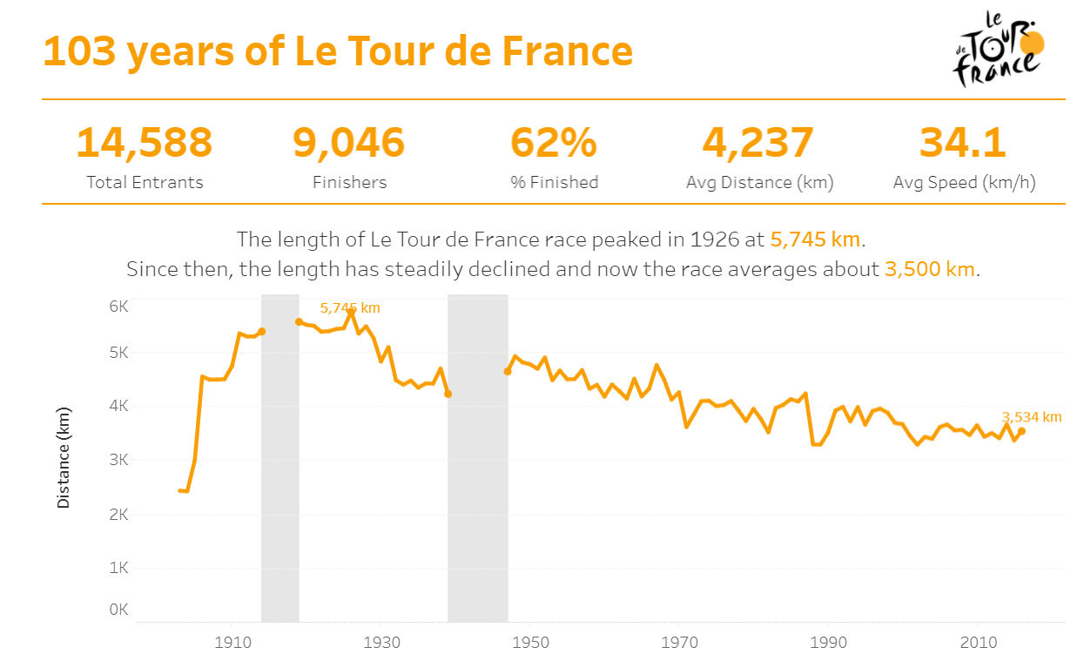
https://www.vizwiz.com/2017/07/tour-de-france.html

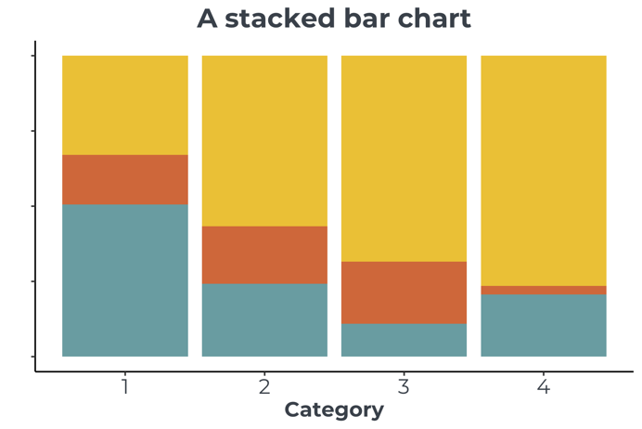

Stacked bar charts can show proportions of a whole and how they change across a varying quantity such as time.

Like an area chart, they are able to demonstrate trends in proportions.

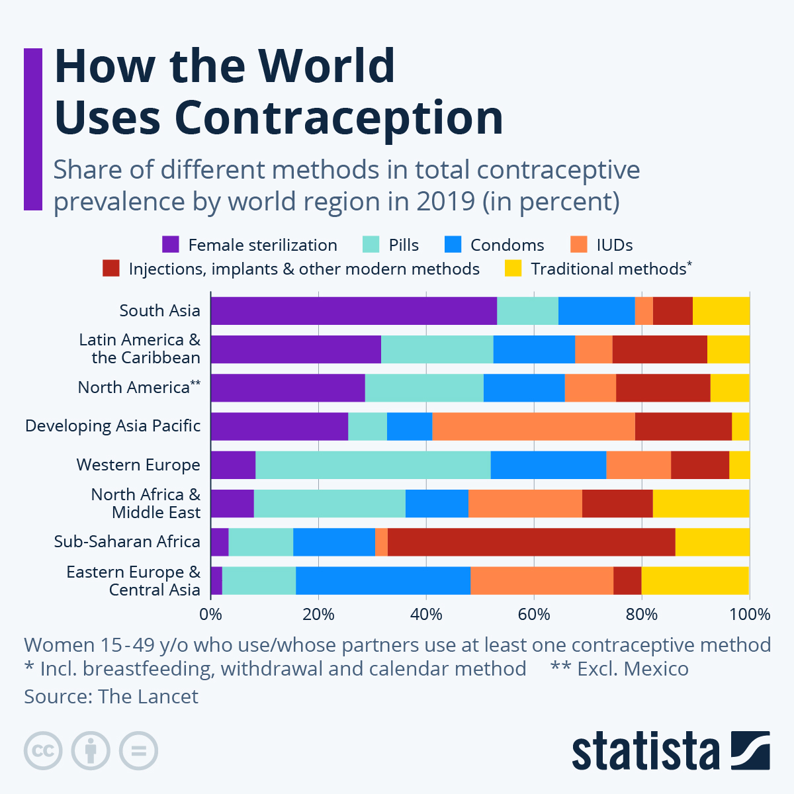
https://www.statista.com/chart/30907/contraceptive-use-by-type/
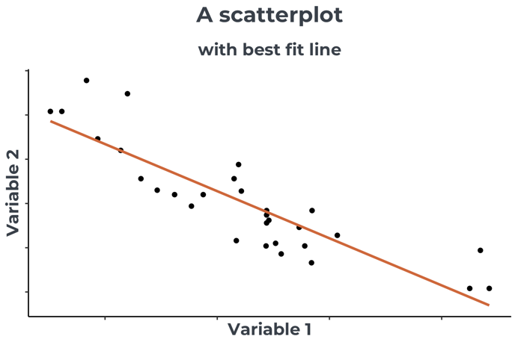
Scatterplots are used to show the relationship between two numerical variables. Both the x-axis and y-axis contain numerical quantities. There is often a line of best fit added to demonstrate the relationship between the two variables.
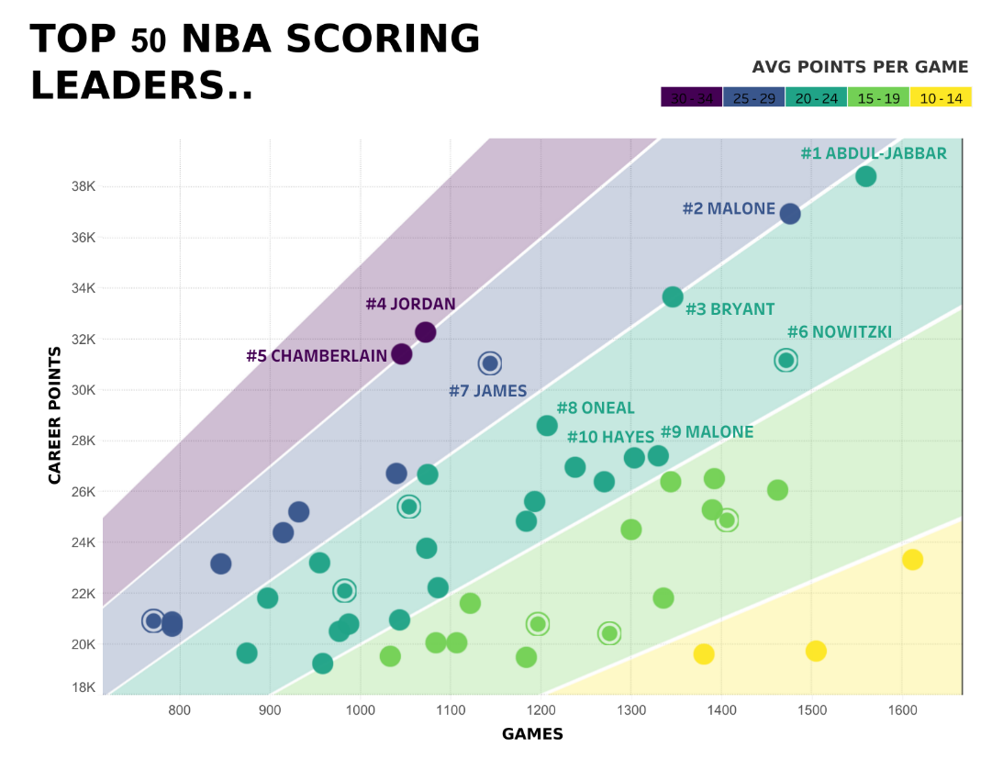
https://public.tableau.com/app/profile/rody.zakovich/viz/TOP50NBASCORINGLEADERS/TOP50NBASCORINGLEADERS
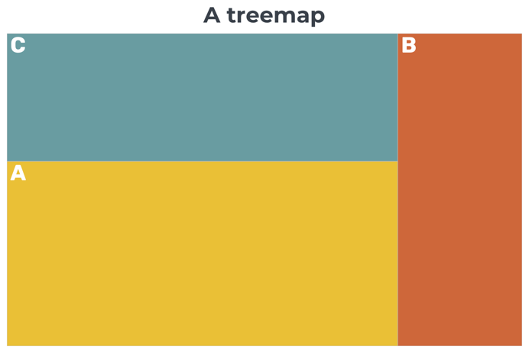

A treemap represents the proportions of a whole, but area rather than angles are used. They are useful for showing subcategories as well as high-level categories.

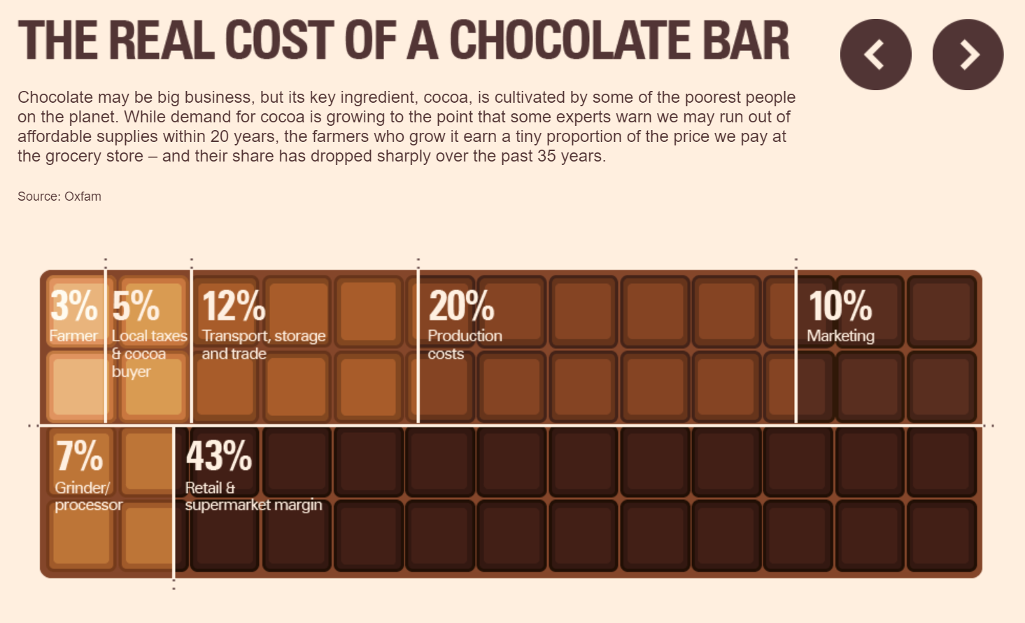
https://malmesbury.wilts.sch.uk/wp-content/uploads/2023/07/Economics-bridging-week-1-Choconomics.pdf

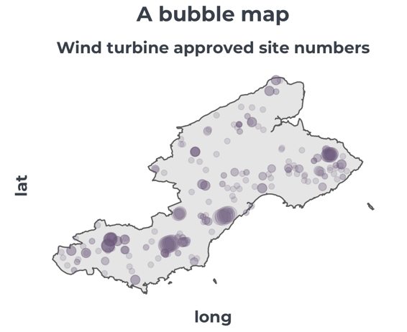
A bubble map shows the magnitude of the variable as well as the spatial distribution of points in a geographic area.

It is good for spotting clusters, however with a large number of bubbles, they can be overplotted and make it more difficult to spot patterns.

It is not easy to extract exact values from bubble maps.

https://www.visualcapitalist.com/covid-19-global-food-insecurity/
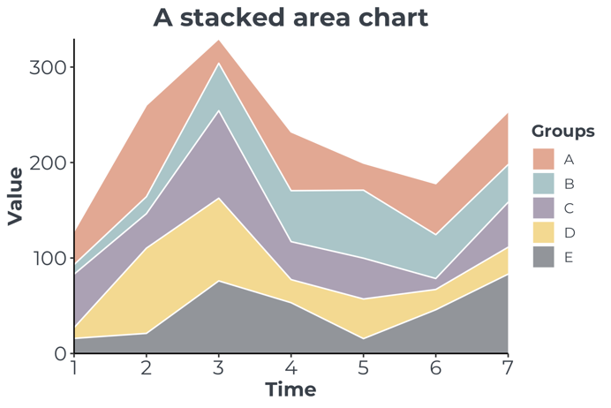

An area chart or a stacked area chart highlights proportions changing over the varying quantity.

As well as raw data volumes, this can also be done as proportions of the whole, which is useful for example in demonstrating the change in survey results over time.

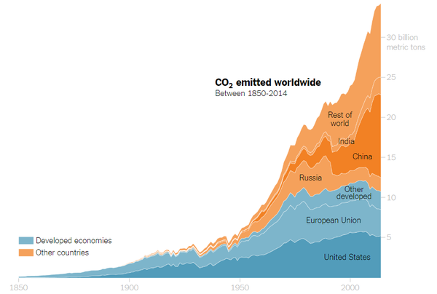
https://www.nytimes.com/2019/02/28/learning/teach-about-climate-change-with-these-24-new-york-times-graphs.html

