RESOURCE

Dear Data

Learning Level: Second (P5 – P7)
PPDAC Framework: Problem|Plan|Data|Analysis|Conclusions
Theme:
- Data Analysis
- Finding & Using Information
Curricular Area: Numeracy | Technologies | Literacy
Duration: 6 x 1 hour sessions
Materials:
- Pen/pencil & paper
- Slides for each lesson
- Data Collection & Tally Chart worksheets
- Sample data (optional)
- Sample visualisations (optional)

Introduction
This resource encompasses 6 lessons as follows:
- An Introduction to Data
- What’s the Story?
- What is it going to look like?
- The Key to Data
- The Visualisation Comes Together
- Evaluation

Curriculum Links
MNU 2-20a: Having discussed the variety of ways and range of media used to present data, I can interpret and draw conclusions from the information displayed, recognising that the presentation may be misleading.
MNU 2-20b: I have carried out investigations and surveys, devising and using a variety of methods to gather information and have worked with others to collate, organise and communicate the results in an appropriate way.
MTH 2-21a: I can display data in a clear way using a suitable scale, by choosing appropriately from an extended range of tables, charts, diagrams and graphs, making effective use of technology.
LIT 2-09a: When listening and talking with others for different purposes, I can: share information, experiences and opinions; explain processes and ideas; identify issues raised and summarise main points or findings; and clarify points by asking questions or by asking others to say more.
TCH 2-11a: I can use a range of graphic techniques, manually and digitally, to communicate ideas, concepts or products, experimenting with the use of shape, colour and texture to enhance my work.

Learning Intentions [Set of 6 lessons]
- How to ask questions to allow more depth to data collected
- How to uncover the story within the collected data
- Using a visualisation to present the data so that others can discover information

Success criteria [Set of 6 lessons]
Have created a data self portrait using:
- Adding depth questions to a data gathering task
- Collecting data to match these questions
- Interpreted the collected data to find the new information
- Created a visualisation to allow fellow students and teachers to discover the information within your data

Lesson 1 – An Introduction to Data

Learning Intentions [This Lesson]
- What is Data Science
- What is data science used for in the real world
- Why do we look for more depth in our data
- How do we get more depth to our data collection

Main Activity
The main activity is split into 2 sections:
Asking Questions: This aligns to the Problem step of PPDAC the data problem solving framework.
Collecting Data: This aligns to the Plan step of PPDAC the data problem solving framework.

The slides contain several pair/group activities including:
Slide 12: Developing in depth questions
Slide 14: Develop the main question and extra depth questions on the topic of media use
Slide 16: Develop the main question and extra depth questions about a book
This lesson explains why collecting more data can allow us to spot patterns and make better decisions.
0-8 minutes: What is data science (vocabulary questions of definition collection, interrogation, and presentation) and What is it used for

8-20 minutes: Water example (Q can you tell me something with the data on the board? Is the person getting enough to drink, can they be more environmentally friendly …)

20-40 minutes: Writing Qs in a group come up with as many questions as possible on the task on the board, the first task follows on from the previous discussions

40-50 minutes: Explain homework task and start on writing depth questions on homework sheet, check students understand task

Homework activity
The final slide details homework to be completed before the next lesson. The data the learners will collect is needed as part of lesson 2. The final part of lesson 1 is helping learners define their questions and complete the template question table in the Data Collection Worksheet.

Lesson 2 – What’s the Story
*Note: if the students have two lessons a week swap lesson 2 and 3)**

Learning Intentions [This Lesson]

To find a story in the data collected

To complete a more complex tally chart

Use a more complex tally chart to explore your data for unusual patterns

Success Criteria [This Lesson]

Found a story in your data

Worked on (hopefully completed) your complex tally chart

Identified any unusual data in your collection

Main Activity
This lesson focuses on investigating the data the students collected in their homework task.
Students count the number of unique answers to each of their questions, then fill in a tally chart to identify common/rare answers, in order to help them find their data question.
The main activity is split into 2 sections:
- A simple visualisation that helps us understand how much data was collected and how many unique answers were obtained.
- A more complex visualisation that shows all the data collected and helps us find a story or patterns in the data.
Both sections aligns to the Analysis step of PPDAC the data problem solving framework.
The Simple Visualisation section requires learners to go through the data they collected since lesson 1 and count up the number of unique answers for each question.
The more complex visualisation extracts the collected data into a matrix style tally chart. All instructions are in the slides. Tally chart template as well as example data are available at the end of this file.
Students should note any reasons for data voids, collecting media and a full day of games on a Monday because there was a school holiday etc
Hold a plenary to discuss the findings. What patterns can they see in their own data.

Lesson 3 - What is it going to look like?

Learning Intentions [This Lesson]
- How to find your interesting data within the tally chart

Success Criteria [This Lesson]
- Identified the interesting data in your tally chart
- Designed three concepts to represent your data
- Designed to layouts on how to divide your final visualisation

Main Activity
The slides explore different and novel ways data can be visualised.
Visualisation is part of the analysis step of PPDAC the data problem solving framework.
Learners should complete two tasks:
- Slide 3: identify interesting data in their tally chart from lesson 2.
- Slide 16: Create your own visualisation

Students should draw one of the items for their theme in the corner of the box, they should then make one change and draw a series of that change (they will need this for choosing which change should represent each questions – if they have five answers and can only think of two changes they will not be able to use that change) size, shape, colour, thickness, angle etc. and repeat this through as many changes as they can.

0-10 minutes: introduce the changes using leaves and lines examples

10- 35 minutes: Three themes expanded on design sheet to show the changes that could form the key (8 min a theme)

35-40 minutes: The layout how to match the topic to the positioning in the final visualisation

40-50 minutes: sketch layouts for two of the three themes.

Lesson 4 - The Key to the Data

Learning Intentions
- Be able to extract relevant information from my data
- Design a theme/key for my visualisation

Success Criteria
- Designed the key for my visualisation
- Started to work on my visualisation using my key

Main Activity
The slides explore different and novel ways data can be visualised.
Visualisation is part of the analysis step of PPDAC the data problem solving framework.
Learners should complete two tasks:
- Slide 3: identify what the example visualisation is about.
- Slide 11: Create a key to their visualisation about their tally chart data.

Working through the tally chart form lesson two, choose one of the changes for the theme and a question and show the answer that a particular version of a change represents (red – tv, blue – radio, green – cinema etc)

Lesson 5 - The Visualisation Comes Together

Learning Intentions [This Lesson]
- I will learn how to create a visualisation from my data

Success Criteria [This Lesson]
- Created my own visualisation about my own data

Main Activity
The slides remind learners of the activities from lesson 4 and then encourage them to complete their visualisation.
Turning the data into a visualisation, using the key from lesson five and the data from the homework turn every box in the homework into a graphic using the key and layout to correctly encode the results.
Visualisation is part of the analysis step of PPDAC the data problem solving framework.
Learners should use the key they developed in lesson 4 to complete their visualisation. Examples are shown in the annex at the end of this document.

Lesson 6 – Evaluation

Learning Intentions [This Lesson]
- I will learn how to create a visualisation from my data

Success Criteria [This Lesson]
- Created my own visualisation about my own data

Main Activity
The slides take learners through a peer evaluation activity where they ask questions of each other's data and visualisation.
In this lesson students will test another student’s key to make sure that they create a data box that looks the same as in the homework.
Then students will look to see if they can find an interesting cluster, grouping, or spread of data in their visualisation. Is there and interesting answer to the question that they created in lesson 2.

Appendix 1: Example Data
Your Questions |  |  |  |  |  |  |  | Answers to your questions
Lvl 1 | How I consumed the media |  |  |  |  |  |  | Lvl 1 | Reading
Lvl 2 | What from |  |  | How long |  |  |  | Lvl 2 | Printed Paper |  |  | 1 Hour
Lvl 3 | Day |  | Time |  | Where |  |  | Lvl 3 | Tuesday |  | 19:00 |  | Living Room
Lvl 4 | Location | Type | Why |  |  |  |  | Lvl 4 | Arm  Chair | Non-Fiction | Work
Answers to your questions |  |  |  |  |  |  |  | Answers to your questions
Lvl 1 | Watching |  |  |  |  |  |  | Lvl 1 | Playing
Lvl 2 | Desktop Computer |  |  | 0.5 Hours |  |  |  | Lvl 2 | Desktop Computer |  |  | 1.5 Hours
Lvl 3 | Tuesday |  | 20:00 |  | Study |  |  | Lvl 3 | Tuesday |  | 20:30 |  | Study
Lvl 4 | Desk  Chair | Youtube | Work |  |  |  |  | Lvl 4 | Desk Chair | Game | Entertainment
Answers to your questions |  |  |  |  |  |  |  | Answers to your questions
Lvl 1 | Listening |  |  |  |  |  |  | Lvl 1 | Watching
Lvl 2 | Phone |  |  | 0.5 Hours |  |  |  | Lvl 2 | TV |  |  | 1 hour
Lvl 3 | Tuesday |  | 22:15 |  | Bedroom |  |  | Lvl 3 | Wednesday |  | 19:00 |  | Living Room
Lvl 4 | Bed | Fiction | Entertainment |  |  |  |  | Lvl 4 | Sofa | Recorded Show | Entertainment
Answers to your questions |  |  |  |  |  |  |  | Answers to your questions
Lvl 1 | Watching |  |  |  |  |  |  | Lvl 1 | Listening
Lvl 2 | TV |  |  | 2 Hours |  |  |  | Lvl 2 | Phone |  |  | 2 Hours
Lvl 3 | Wednesday |  | 20:00 |  | Living Room |  |  | Lvl 3 | Wednesday |  | 17:00 |  | Study
Lvl 4 | Sofa | Amazon Prime | Entertainment |  |  |  |  | Lvl 4 | Desk  Chair | Podcast  App | Entertainment
Answers to your questions |  |  |  |  |  |  |  | Answers to your questions
Lvl 1 | Listening |  |  |  |  |  |  | Lvl 1 | Watching
Lvl 2 | Phone |  |  | 0.5 Hours |  |  |  | Lvl 2 | TV |  |  | 1 Hour
Lvl 3 | Wednesday |  | 22:10 |  | Bedroom |  |  | Lvl 3 | Thursday |  | 17:00 |  | Kitchen
Lvl 4 | Bed | Fiction | Entertainment |  |  |  |  | Lvl 4 | Standing | Recorded Show | Background
Answers to your questions |  |  |  |  |  |  |  | Answers to your questions
Lvl 1 | Watching |  |  |  |  |  |  | Lvl 1 | Listening
Lvl 2 | TV |  |  | 1.5 Hours |  |  |  | Lvl 2 | Phone |  |  | 1.5 Hours
Lvl 3 | Thursday |  | 18:00 |  | Living Room |  |  | Lvl 3 | Thursday |  | 20:00 |  | Study
Lvl 4 | Sofa | Netflix | Entertainment |  |  |  |  | Lvl 4 | Desk Chair | Podcast | Background
Answers to your questions |  |  |  |  |  |  |  | Answers to your questions
Lvl 1 | Reading |  |  |  |  |  |  | Lvl 1 | Listening
Lvl 2 | Real Book |  |  | 0.33 Hours |  |  |  | Lvl 2 | Phone |  |  | 0.5 Hours
Lvl 3 | Thursday |  | 21:40 |  | Bedroom |  |  | Lvl 3 | Thursday |  | 22:00 |  | Bedroom
Lvl 4 | Bed | Non-fiction | Work |  |  |  |  | Lvl 4 | Bed | Fiction | Entertainment
Answers to your questions |  |  |  |  |  |  |  | Answers to your questions
Lvl 1 | Watching |  |  |  |  |  |  | Lvl 1 | Watching
Lvl 2 | Cinema Screen |  |  | 3 hours |  |  |  | Lvl 2 | TV |  |  | 0.75 Hours
Lvl 3 | Friday |  | 15:30 |  | Cinema |  |  | Lvl 3 | Friday |  | 20:45 |  | Kitchen
Lvl 4 | Seat | Movie | Entertainment |  |  |  |  | Lvl 4 | Standing | TV show | Background
Answers to your questions |  |  |  |  |  |  |  | Answers to your questions
Lvl 1 | Watching |  |  |  |  |  |  | Lvl 1 | Listening
Lvl 2 | TV |  |  | 1.5 Hours |  |  |  | Lvl 2 | Phone |  |  | 0.5 Hours
Lvl 3 | Friday |  | 21:30 |  | Living Room |  |  | Lvl 3 | Friday |  | 23:15 |  | Bedroom
Lvl 4 | Sofa | Netflix | Entertainment |  |  |  |  | Lvl 4 | Bed | Fiction | Entertainment
Answers to your questions |  |  |  |  |  |  |  | Answers to your questions
Lvl 1 | Watching |  |  |  |  |  |  | Lvl 1 | Watching
Lvl 2 | Desktop Computer |  |  | 1.5 Hours |  |  |  | Lvl 2 | iPad |  |  | 3.5 Hours
Lvl 3 | Saturday |  | 07:00 |  | Study |  |  | Lvl 3 | Saturday |  | 18:30 |  | Study
Lvl 4 | Desk Chair | Twitch | Kill Time - Waiting |  |  |  |  | Lvl 4 | Desk Chair | Twitch | Entertainment
Answers to your questions |  |  |  |  |  |  |  | Answers to your questions
Lvl 1 | Playing |  |  |  |  |  |  | Lvl 1 | Reading
Lvl 2 | Desktop Computer |  |  | 3.5 Hours |  |  |  | Lvl 2 | Real Book |  |  | .75 Hours
Lvl 3 | Saturday |  | 18:30 |  | Study |  |  | Lvl 3 | Saturday |  | 22:15 |  | Bedroom
Lvl 4 | Desk Chair | Game | Entertainment |  |  |  |  | Lvl 4 | Bed | Non-fiction | Entertainment
Answers to your questions |  |  |  |  |  |  |  | Answers to your questions
Lvl 1 | Listening |  |  |  |  |  |  | Lvl 1 | Watching
Lvl 2 | Phone |  |  | .5 Hours |  |  |  | Lvl 2 | TV |  |  | 1.5 Hours
Lvl 3 | Saturday |  | 23:00 |  | Bedroom |  |  | Lvl 3 | Sunday |  | 07:00 |  | Living Room
Lvl 4 | Bed | Podcast | Entertainment |  |  |  |  | Lvl 4 | Arm Chair | TV show | Entertainment
Answers to your questions |  |  |  |  |  |  |  | Answers to your questions
Lvl 1 | Reading |  |  |  |  |  |  | Lvl 1 | Listening
Lvl 2 | Real book |  |  | 1 Hour |  |  |  | Lvl 2 | Record |  |  | 1 Hour
Lvl 3 | Sunday |  | 09:00 |  | Balcony |  |  | Lvl 3 | Sunday |  | 10:00 |  | Living Room
Lvl 4 | Bench | Non-fiction | Entertainment |  |  |  |  | Lvl 4 | Dinning Table | Music | Entertainment
Answers to your questions |  |  |  |  |  |  |  | Answers to your questions
Lvl 1 | Listening |  |  |  |  |  |  | Lvl 1 | Listening
Lvl 2 | Phone |  |  | 1 Hour |  |  |  | Lvl 2 | Phone |  |  | 1.5 Hours
Lvl 3 | Sunday |  | 11:15 |  | Outside |  |  | Lvl 3 | Sunday |  | 12:45 |  | Kitchen
Lvl 4 | Walking | Non-fiction | Entertainment |  |  |  |  | Lvl 4 | Standing | Music | Entertainment
Answers to your questions |  |  |  |  |  |  |  | Answers to your questions
Lvl 1 | Playing |  |  |  |  |  |  | Lvl 1 | Watching
Lvl 2 | Desktop Computer |  |  | 8 Hours |  |  |  | Lvl 2 | TV |  |  | 0.5 Hours
Lvl 3 | Sunday |  | 14:30 |  | Study |  |  | Lvl 3 | Monday |  | 06:15 |  | Living Room
Lvl 4 | Desk Chair | Game | Entertainment |  |  |  |  | Lvl 4 | Dinning Table | Netflix | Background

Appendix 2: Data Collection Template
Student name:
Student class:
Collection start date: |  | Collection end date:

Your Task:
- Choose one of the following data categories:
    - What media did you consume this week? (Tv, film, books, comics, radio, music, etc)
    - What did you drink this week?
    - What books do you have at home?
    - What clothes do you own?
    - What mobile apps did you used this week
- Using what we have learned collect data over the course of the next week [starting today]
- Remember to use questions to get more depth to your data

Example: Questions |  |  |  |  |  |  |  | Example: Answers
Lvl 1 | How I consumed the media |  |  |  |  |  |  | Lvl 1 | Film I was watching
Lvl 2 | What from |  |  | How long |  |  |  | Lvl 2 | Alone |  |  | 15:00
Lvl 3 | Day |  | Time |  | Where |  |  | Lvl 3 | Home |  | Sunday |  | Living Room
Lvl 4 | Location | Type | Why |  |  |  |  | Lvl 4 | Loud | Sitting | Entertainment

Your questions |  |  |  |  |  |  |  | Answers to your questions
Lvl 1 |  |  |  |  |  |  |  | Lvl 1
Lvl 2 |  |  |  |  |  |  |  | Lvl 2
Lvl 3 |  |  |  |  |  |  |  | Lvl 3
Lvl 4 |  |  |  |  |  |  |  | Lvl 4
Answers to your questions |  |  |  |  |  |  |  | Answers to your questions
Lvl 1 |  |  |  |  |  |  |  | Lvl 1
Lvl 2 |  |  |  |  |  |  |  | Lvl 2
Lvl 3 |  |  |  |  |  |  |  | Lvl 3
Lvl 4 |  |  |  |  |  |  |  | Lvl 4
Answers to your questions |  |  |  |  |  |  |  | Answers to your questions
Lvl 1 |  |  |  |  |  |  |  | Lvl 1
Lvl 2 |  |  |  |  |  |  |  | Lvl 2
Lvl 3 |  |  |  |  |  |  |  | Lvl 3
Lvl 4 |  |  |  |  |  |  |  | Lvl 4
Answers to your questions |  |  |  |  |  |  |  | Answers to your questions
Lvl 1 |  |  |  |  |  |  |  | Lvl 1
Lvl 2 |  |  |  |  |  |  |  | Lvl 2
Lvl 3 |  |  |  |  |  |  |  | Lvl 3
Lvl 4 |  |  |  |  |  |  |  | Lvl 4
Answers to your questions |  |  |  |  |  |  |  | Answers to your questions
Lvl 1 |  |  |  |  |  |  |  | Lvl 1
Lvl 2 |  |  |  |  |  |  |  | Lvl 2
Lvl 3 |  |  |  |  |  |  |  | Lvl 3
Lvl 4 |  |  |  |  |  |  |  | Lvl 4
Answers to your questions |  |  |  |  |  |  |  | Answers to your questions
Lvl 1 |  |  |  |  |  |  |  | Lvl 1
Lvl 2 |  |  |  |  |  |  |  | Lvl 2
Lvl 3 |  |  |  |  |  |  |  | Lvl 3
Lvl 4 |  |  |  |  |  |  |  | Lvl 4
Answers to your questions |  |  |  |  |  |  |  | Answers to your questions
Lvl 1 |  |  |  |  |  |  |  | Lvl 1
Lvl 2 |  |  |  |  |  |  |  | Lvl 2
Lvl 3 |  |  |  |  |  |  |  | Lvl 3
Lvl 4 |  |  |  |  |  |  |  | Lvl 4
Answers to your questions |  |  |  |  |  |  |  | Answers to your questions
Lvl 1 |  |  |  |  |  |  |  | Lvl 1
Lvl 2 |  |  |  |  |  |  |  | Lvl 2
Lvl 3 |  |  |  |  |  |  |  | Lvl 3
Lvl 4 |  |  |  |  |  |  |  | Lvl 4
Answers to your questions |  |  |  |  |  |  |  | Answers to your questions
Lvl 1 |  |  |  |  |  |  |  | Lvl 1
Lvl 2 |  |  |  |  |  |  |  | Lvl 2
Lvl 3 |  |  |  |  |  |  |  | Lvl 3
Lvl 4 |  |  |  |  |  |  |  | Lvl 4
Answers to your questions |  |  |  |  |  |  |  | Answers to your questions
Lvl 1 |  |  |  |  |  |  |  | Lvl 1
Lvl 2 |  |  |  |  |  |  |  | Lvl 2
Lvl 3 |  |  |  |  |  |  |  | Lvl 3
Lvl 4 |  |  |  |  |  |  |  | Lvl 4
Answers to your questions |  |  |  |  |  |  |  | Answers to your questions
Lvl 1 |  |  |  |  |  |  |  | Lvl 1
Lvl 2 |  |  |  |  |  |  |  | Lvl 2
Lvl 3 |  |  |  |  |  |  |  | Lvl 3
Lvl 4 |  |  |  |  |  |  |  | Lvl 4
Answers to your questions |  |  |  |  |  |  |  | Answers to your questions
Lvl 1 |  |  |  |  |  |  |  | Lvl 1
Lvl 2 |  |  |  |  |  |  |  | Lvl 2
Lvl 3 |  |  |  |  |  |  |  | Lvl 3
Lvl 4 |  |  |  |  |  |  |  | Lvl 4
Answers to your questions |  |  |  |  |  |  |  | Answers to your questions
Lvl 1 |  |  |  |  |  |  |  | Lvl 1
Lvl 2 |  |  |  |  |  |  |  | Lvl 2
Lvl 3 |  |  |  |  |  |  |  | Lvl 3
Lvl 4 |  |  |  |  |  |  |  | Lvl 4
Answers to your questions |  |  |  |  |  |  |  | Answers to your questions
Lvl 1 |  |  |  |  |  |  |  | Lvl 1
Lvl 2 |  |  |  |  |  |  |  | Lvl 2
Lvl 3 |  |  |  |  |  |  |  | Lvl 3
Lvl 4 |  |  |  |  |  |  |  | Lvl 4
Answers to your questions |  |  |  |  |  |  |  | Answers to your questions
Lvl 1 |  |  |  |  |  |  |  | Lvl 1
Lvl 2 |  |  |  |  |  |  |  | Lvl 2
Lvl 3 |  |  |  |  |  |  |  | Lvl 3
Lvl 4 |  |  |  |  |  |  |  | Lvl 4
Answers to your questions |  |  |  |  |  |  |  | Answers to your questions
Lvl 1 |  |  |  |  |  |  |  | Lvl 1
Lvl 2 |  |  |  |  |  |  |  | Lvl 2
Lvl 3 |  |  |  |  |  |  |  | Lvl 3
Lvl 4 |  |  |  |  |  |  |  | Lvl 4
Answers to your questions |  |  |  |  |  |  |  | Answers to your questions
Lvl 1 |  |  |  |  |  |  |  | Lvl 1
Lvl 2 |  |  |  |  |  |  |  | Lvl 2
Lvl 3 |  |  |  |  |  |  |  | Lvl 3
Lvl 4 |  |  |  |  |  |  |  | Lvl 4
Answers to your questions |  |  |  |  |  |  |  | Answers to your questions
Lvl 1 |  |  |  |  |  |  |  | Lvl 1
Lvl 2 |  |  |  |  |  |  |  | Lvl 2
Lvl 3 |  |  |  |  |  |  |  | Lvl 3
Lvl 4 |  |  |  |  |  |  |  | Lvl 4
Answers to your questions |  |  |  |  |  |  |  | Answers to your questions
Lvl 1 |  |  |  |  |  |  |  | Lvl 1
Lvl 2 |  |  |  |  |  |  |  | Lvl 2
Lvl 3 |  |  |  |  |  |  |  | Lvl 3
Lvl 4 |  |  |  |  |  |  |  | Lvl 4
Answers to your questions |  |  |  |  |  |  |  | Answers to your questions
Lvl 1 |  |  |  |  |  |  |  | Lvl 1
Lvl 2 |  |  |  |  |  |  |  | Lvl 2
Lvl 3 |  |  |  |  |  |  |  | Lvl 3
Lvl 4 |  |  |  |  |  |  |  | Lvl 4

Appendix 3: Tally Chart Template
Name: |  |  |  |  |  |  |  |  |  |  |  |  |  | Topic:
Class: |  |  |  |  |  |  |  |  |  |  |  |  |  | Main Question:
Data Science: Number of Unique Answers at Each Level
Lvl1
Lvl2
Lvl3
Lvl4

Other data
Main Focus ↓

Appendix 4: Example Visualisations
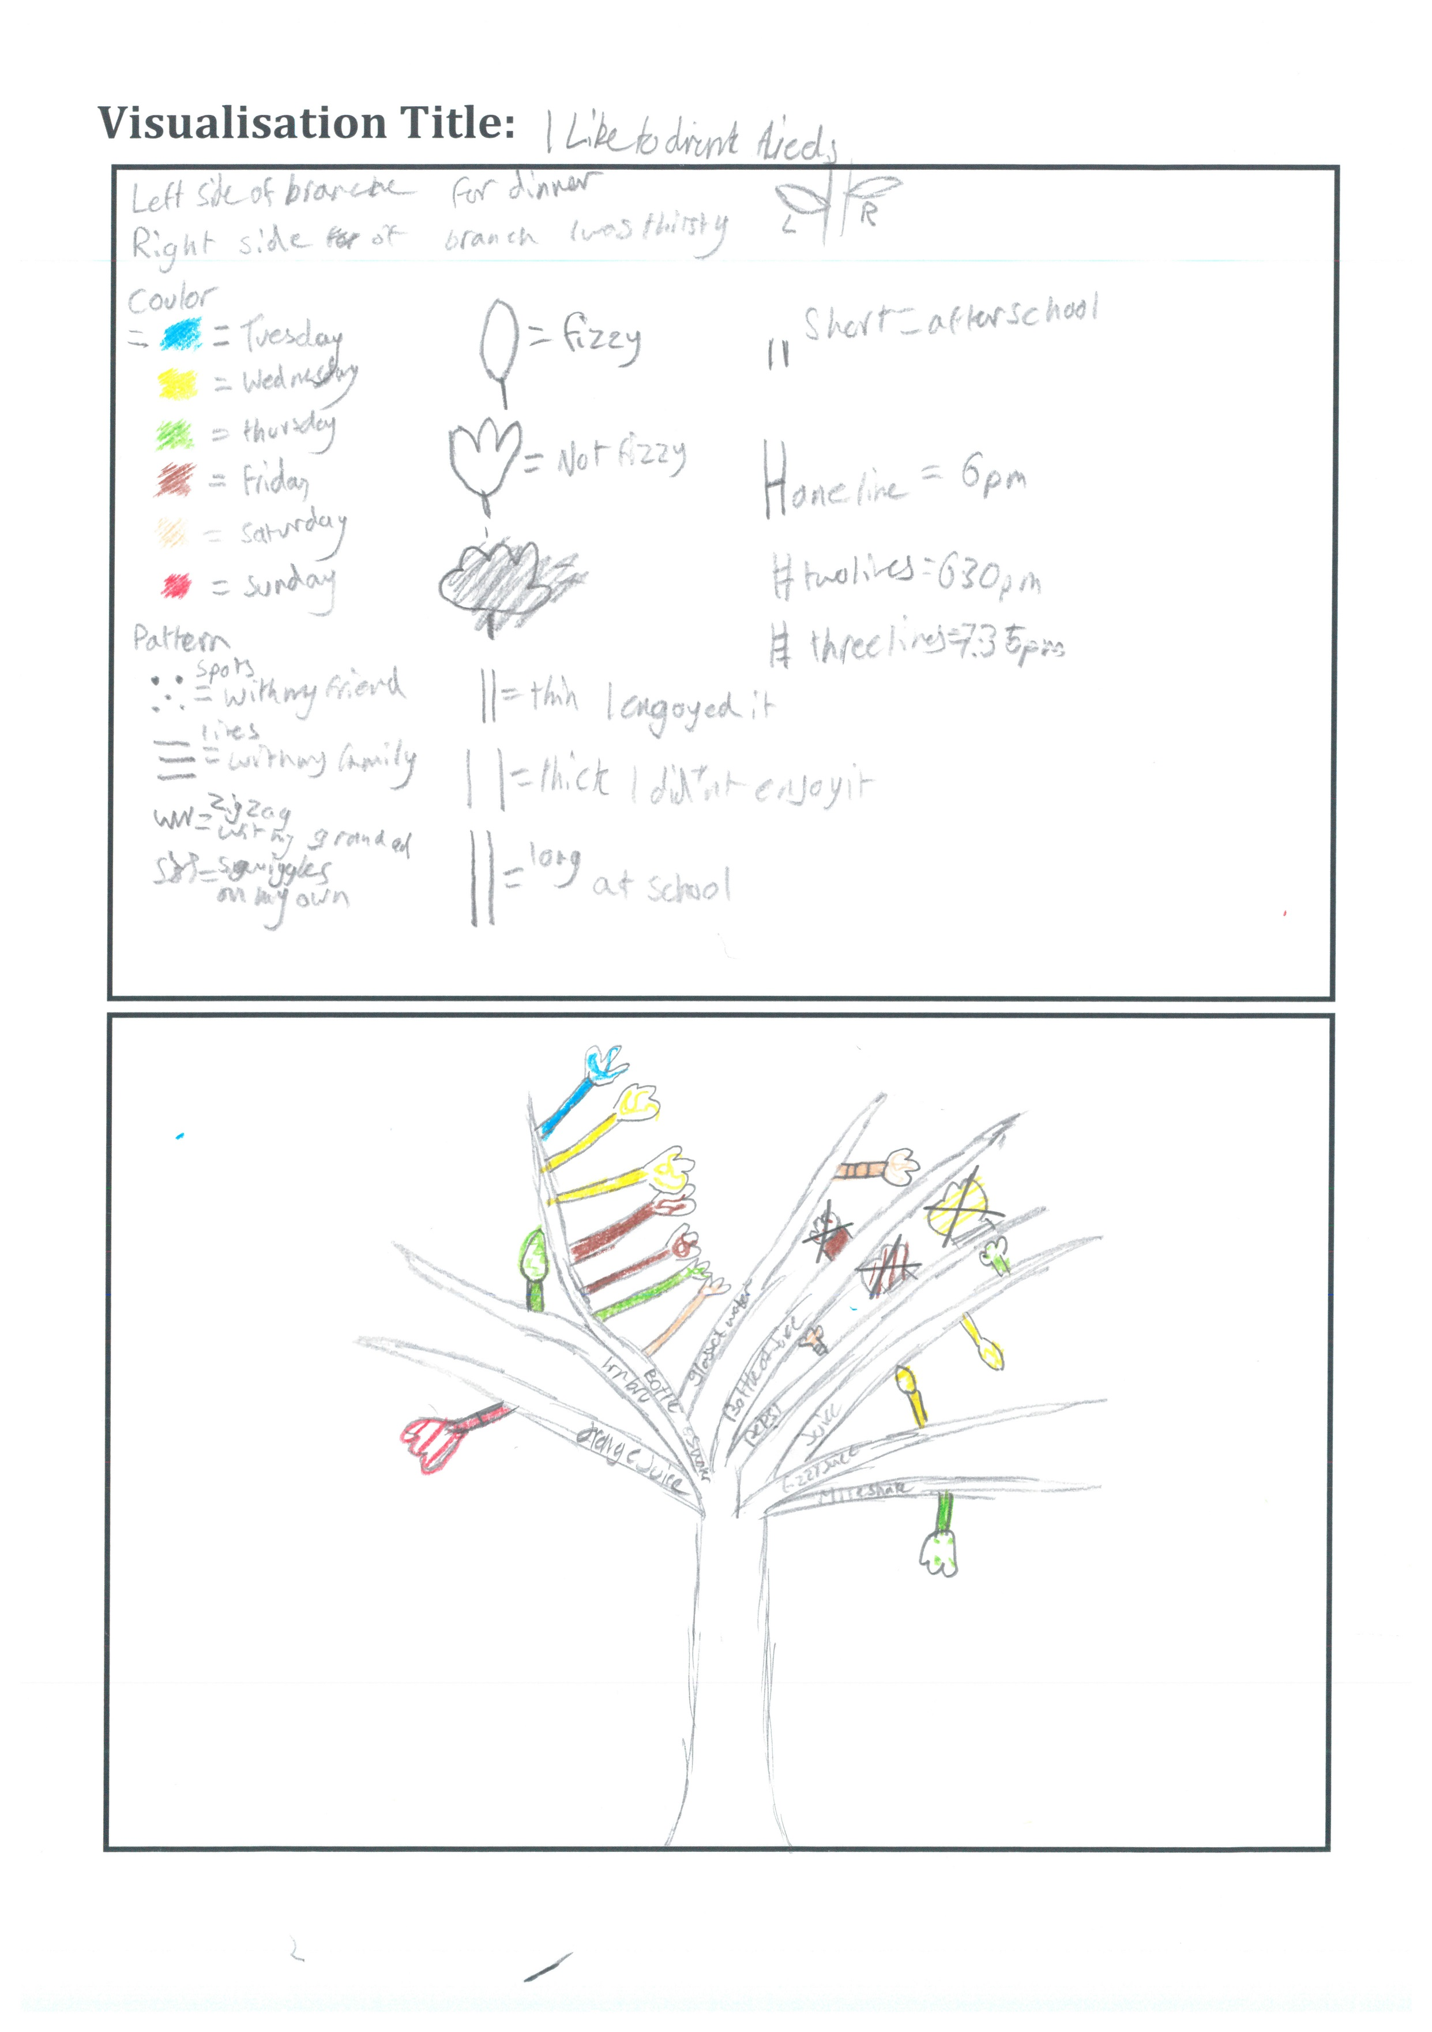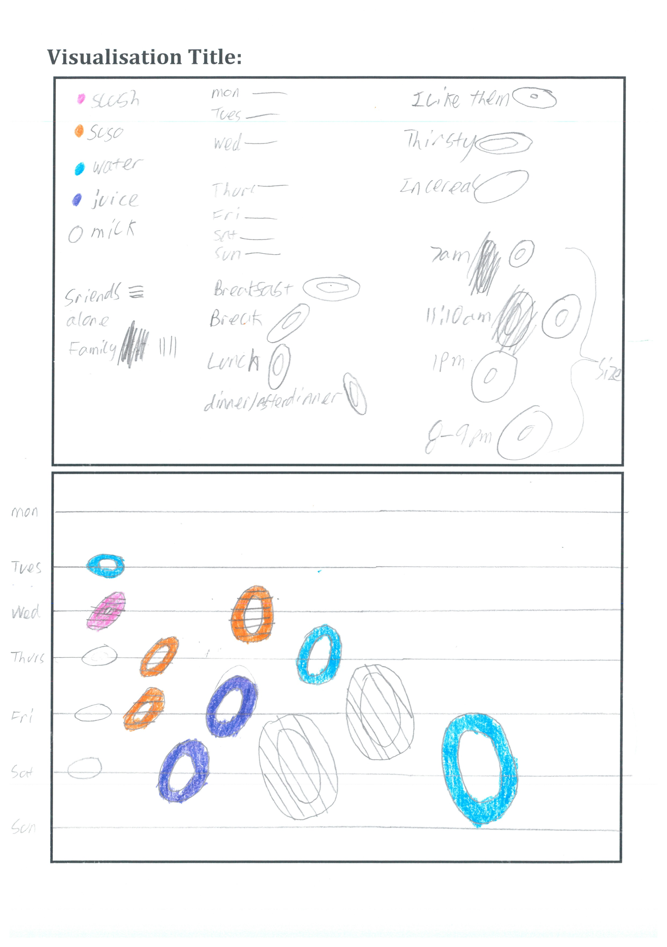

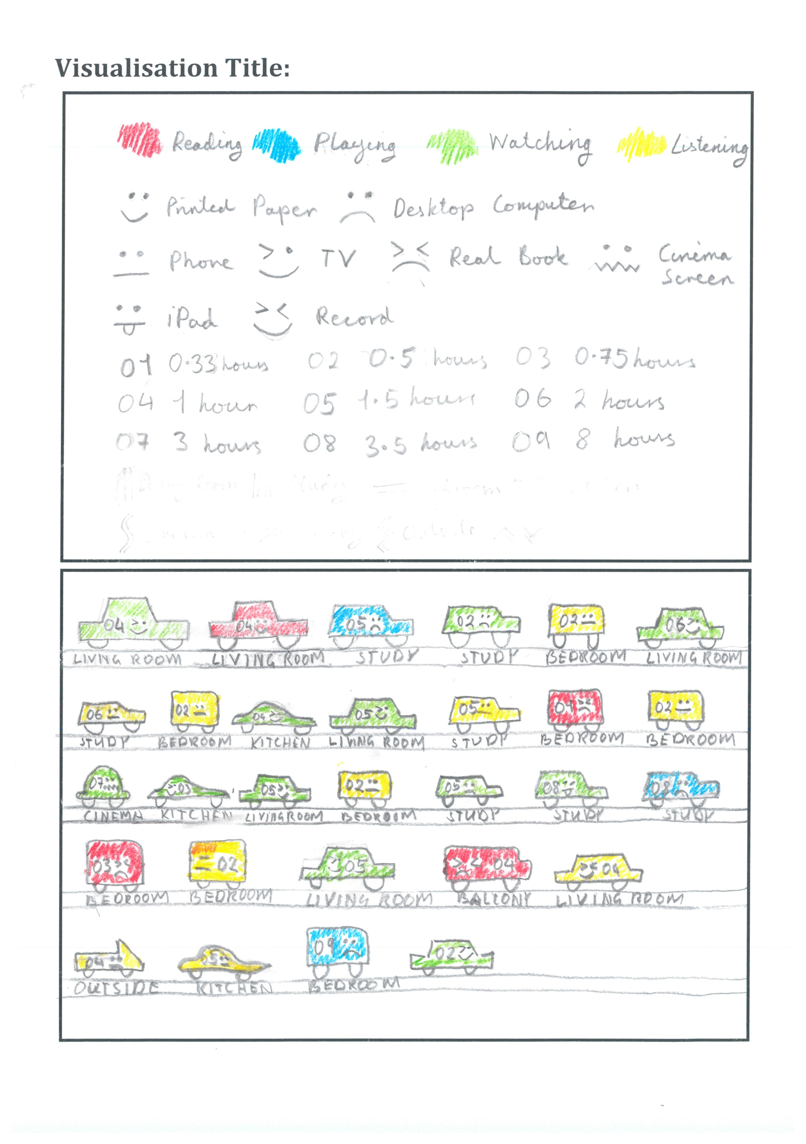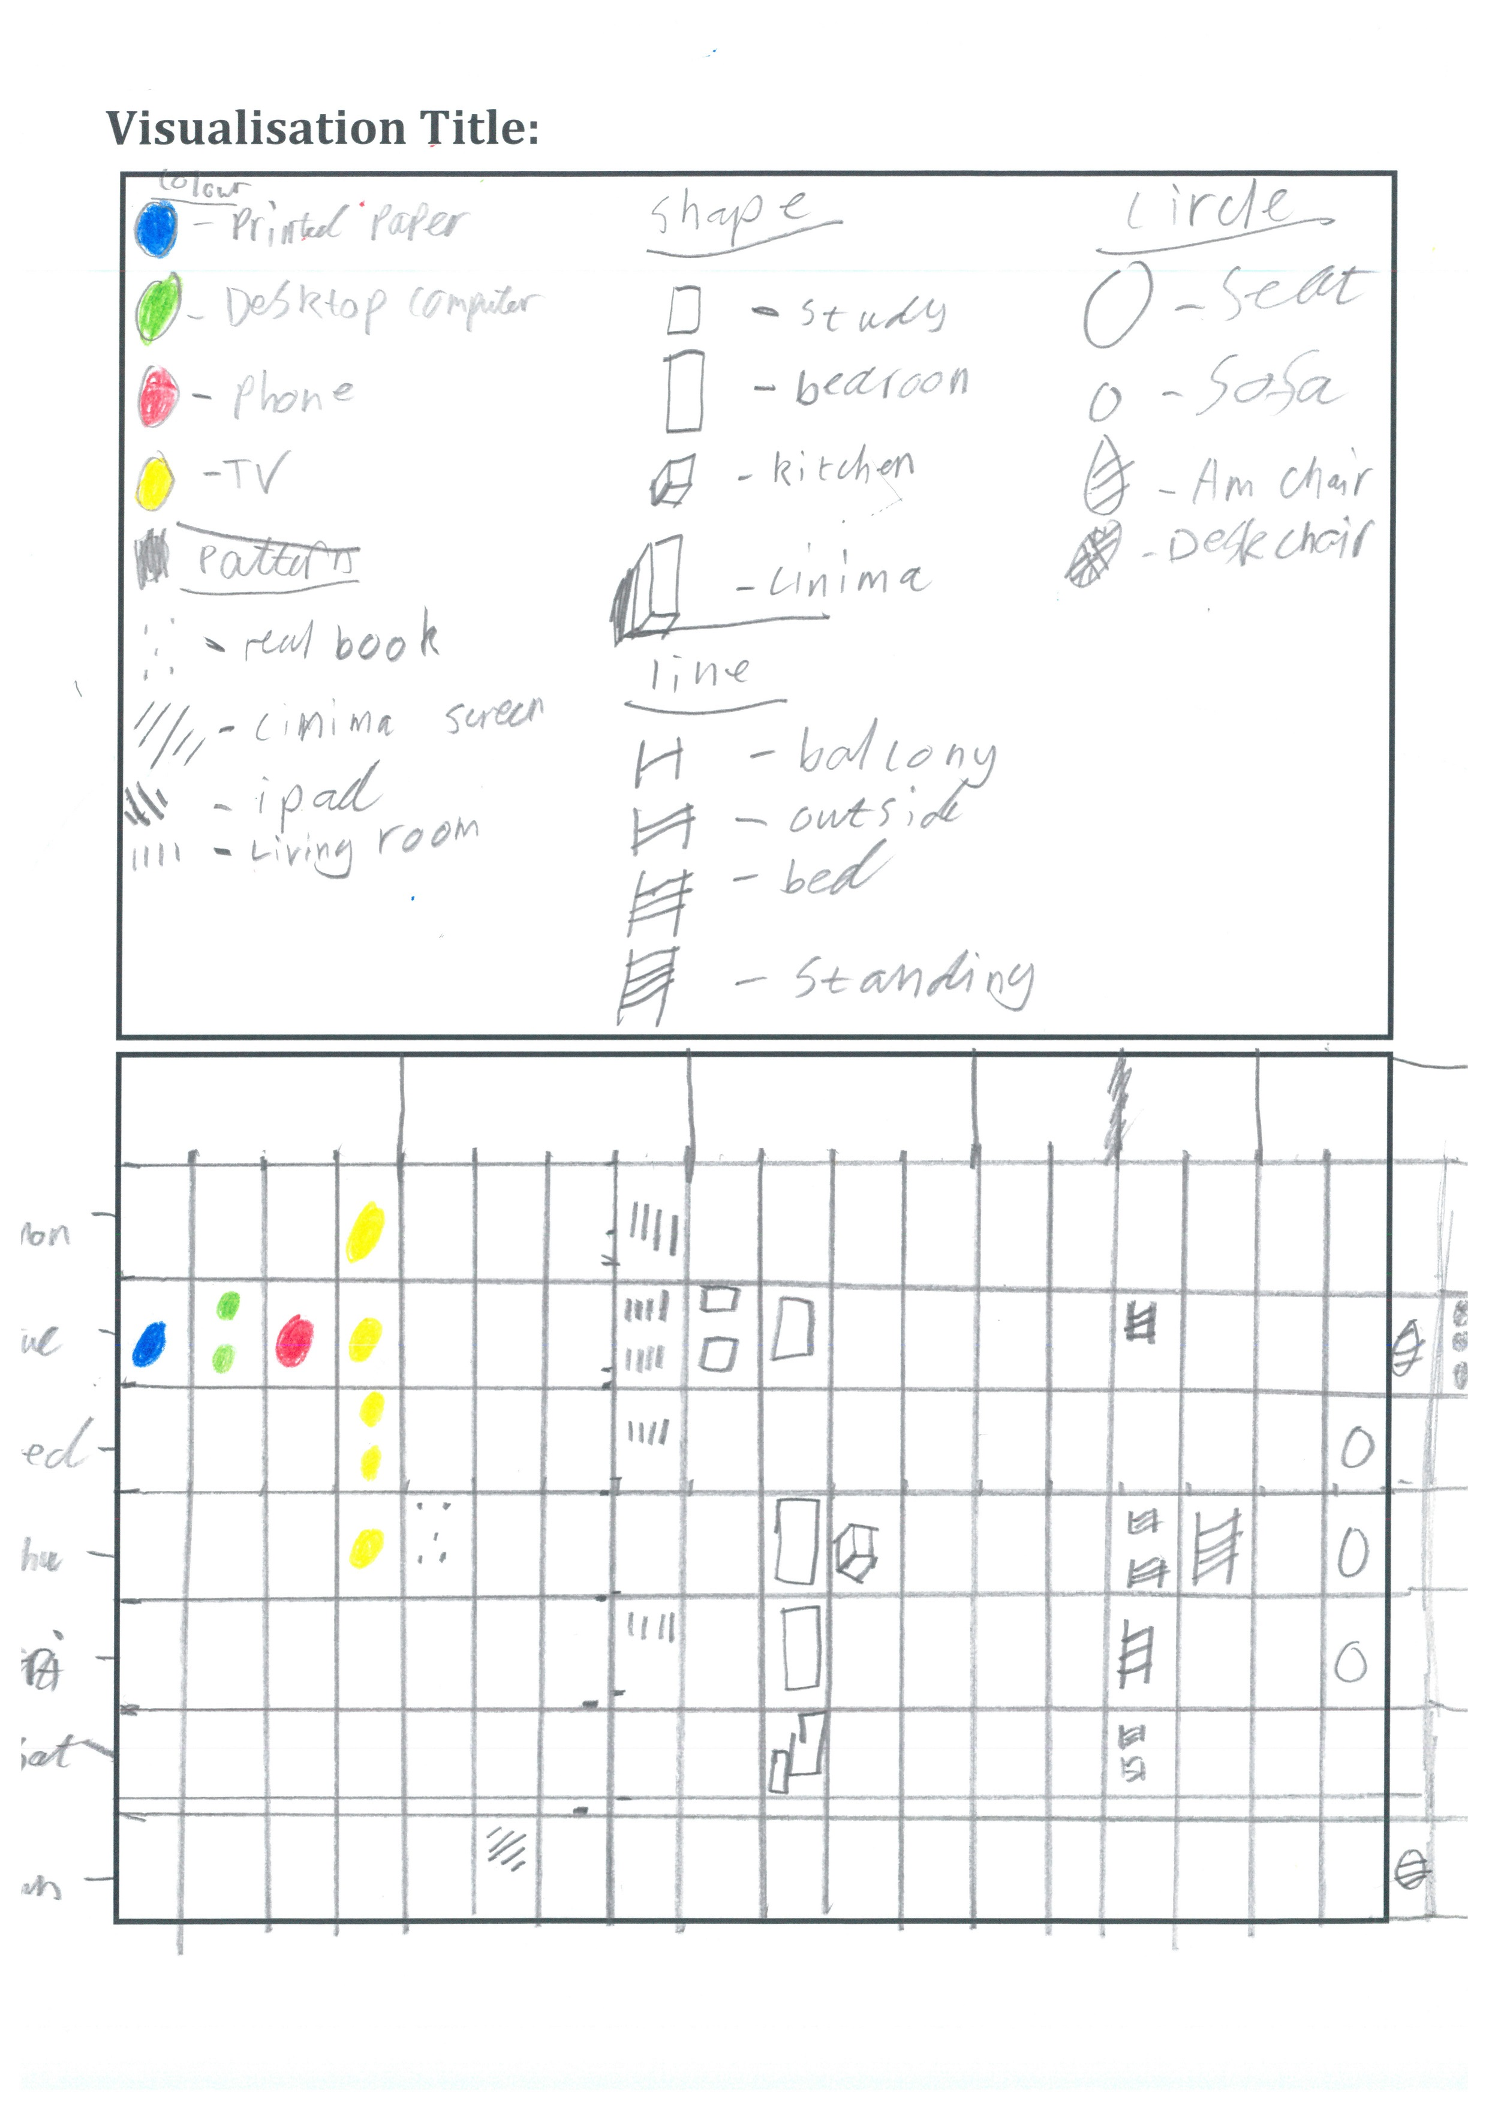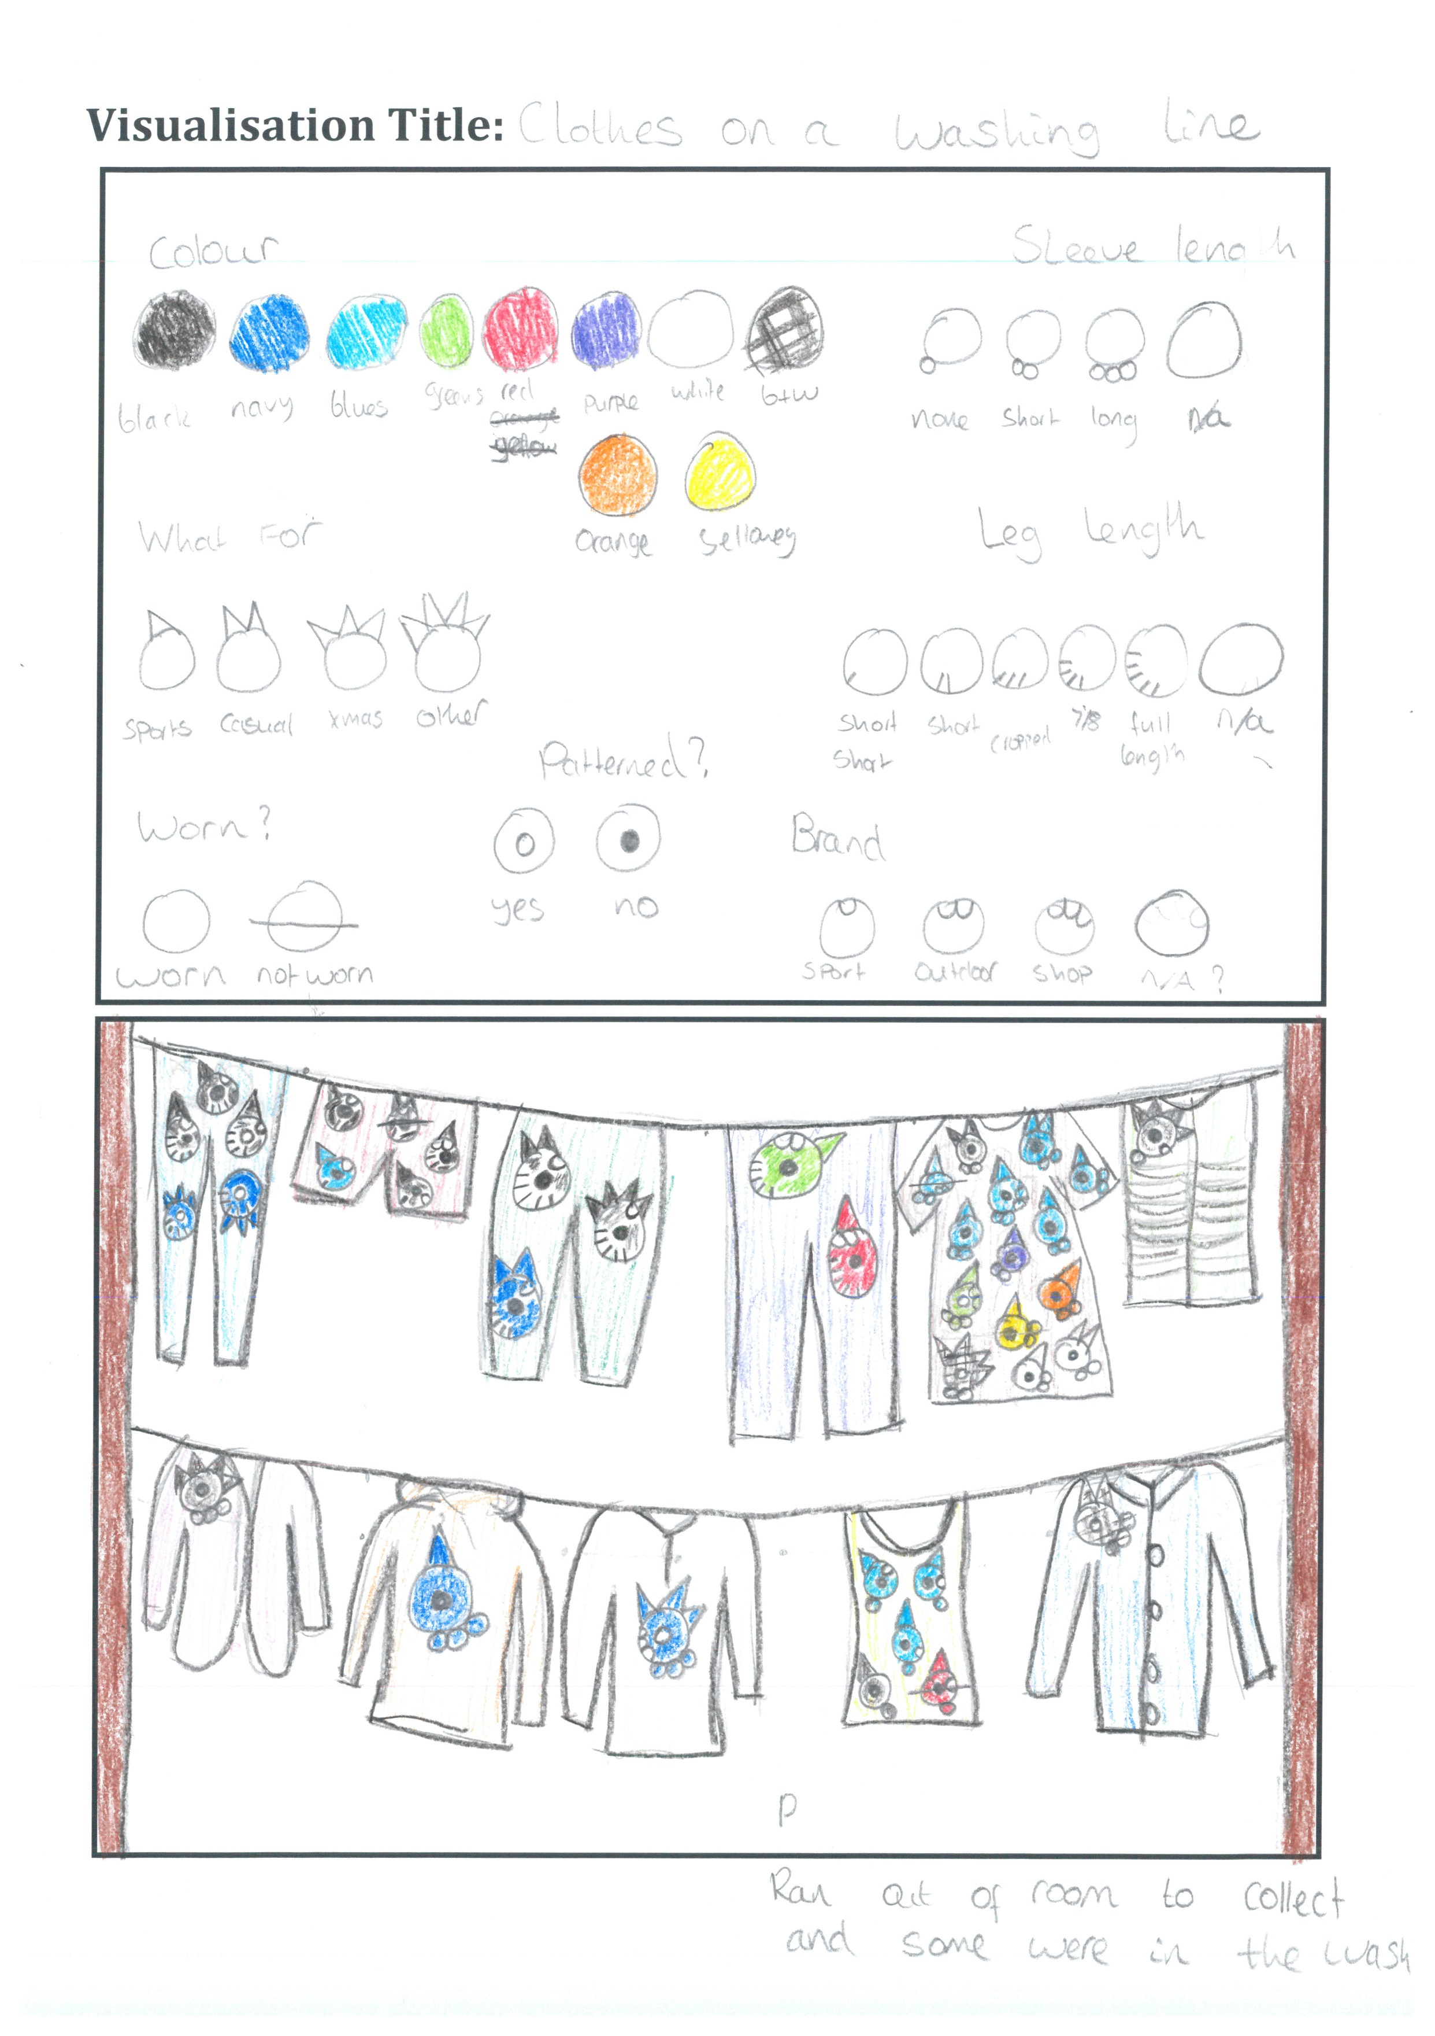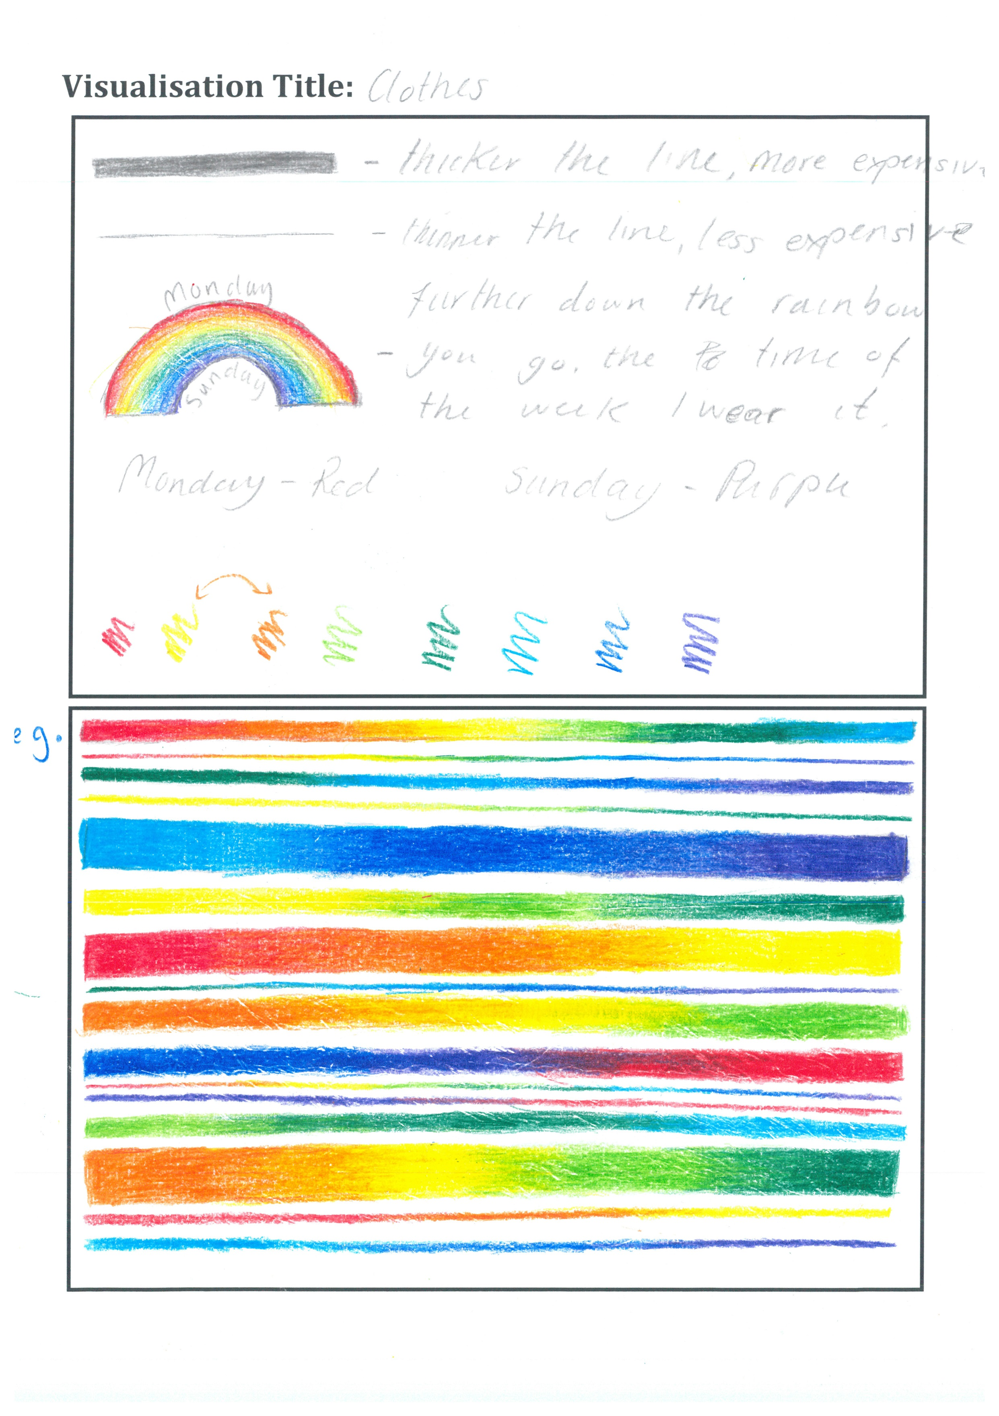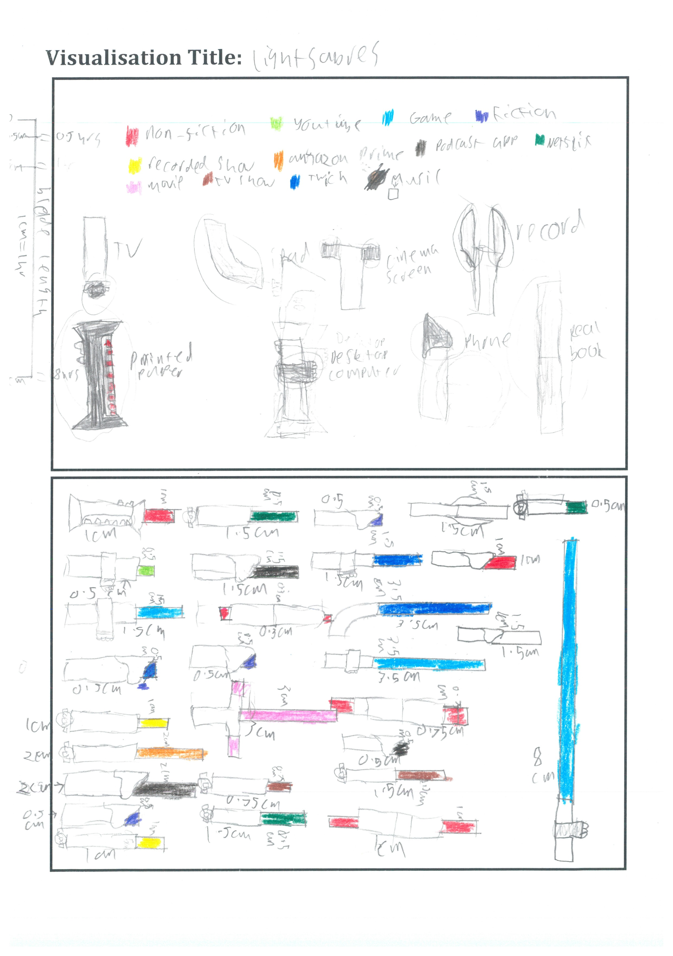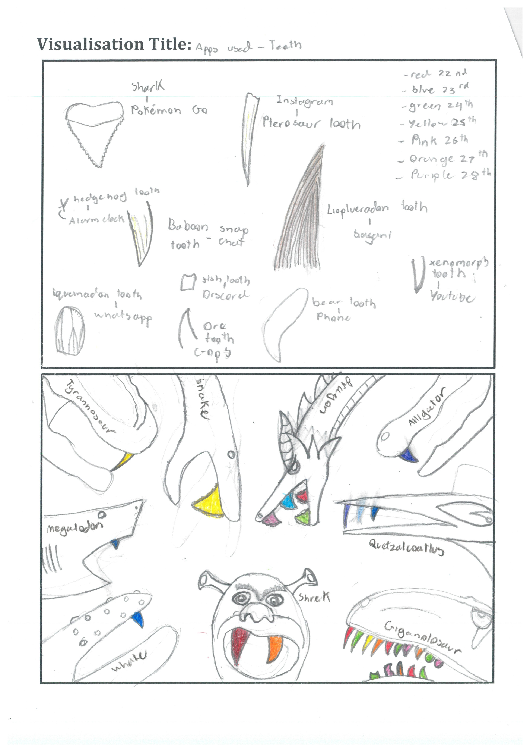
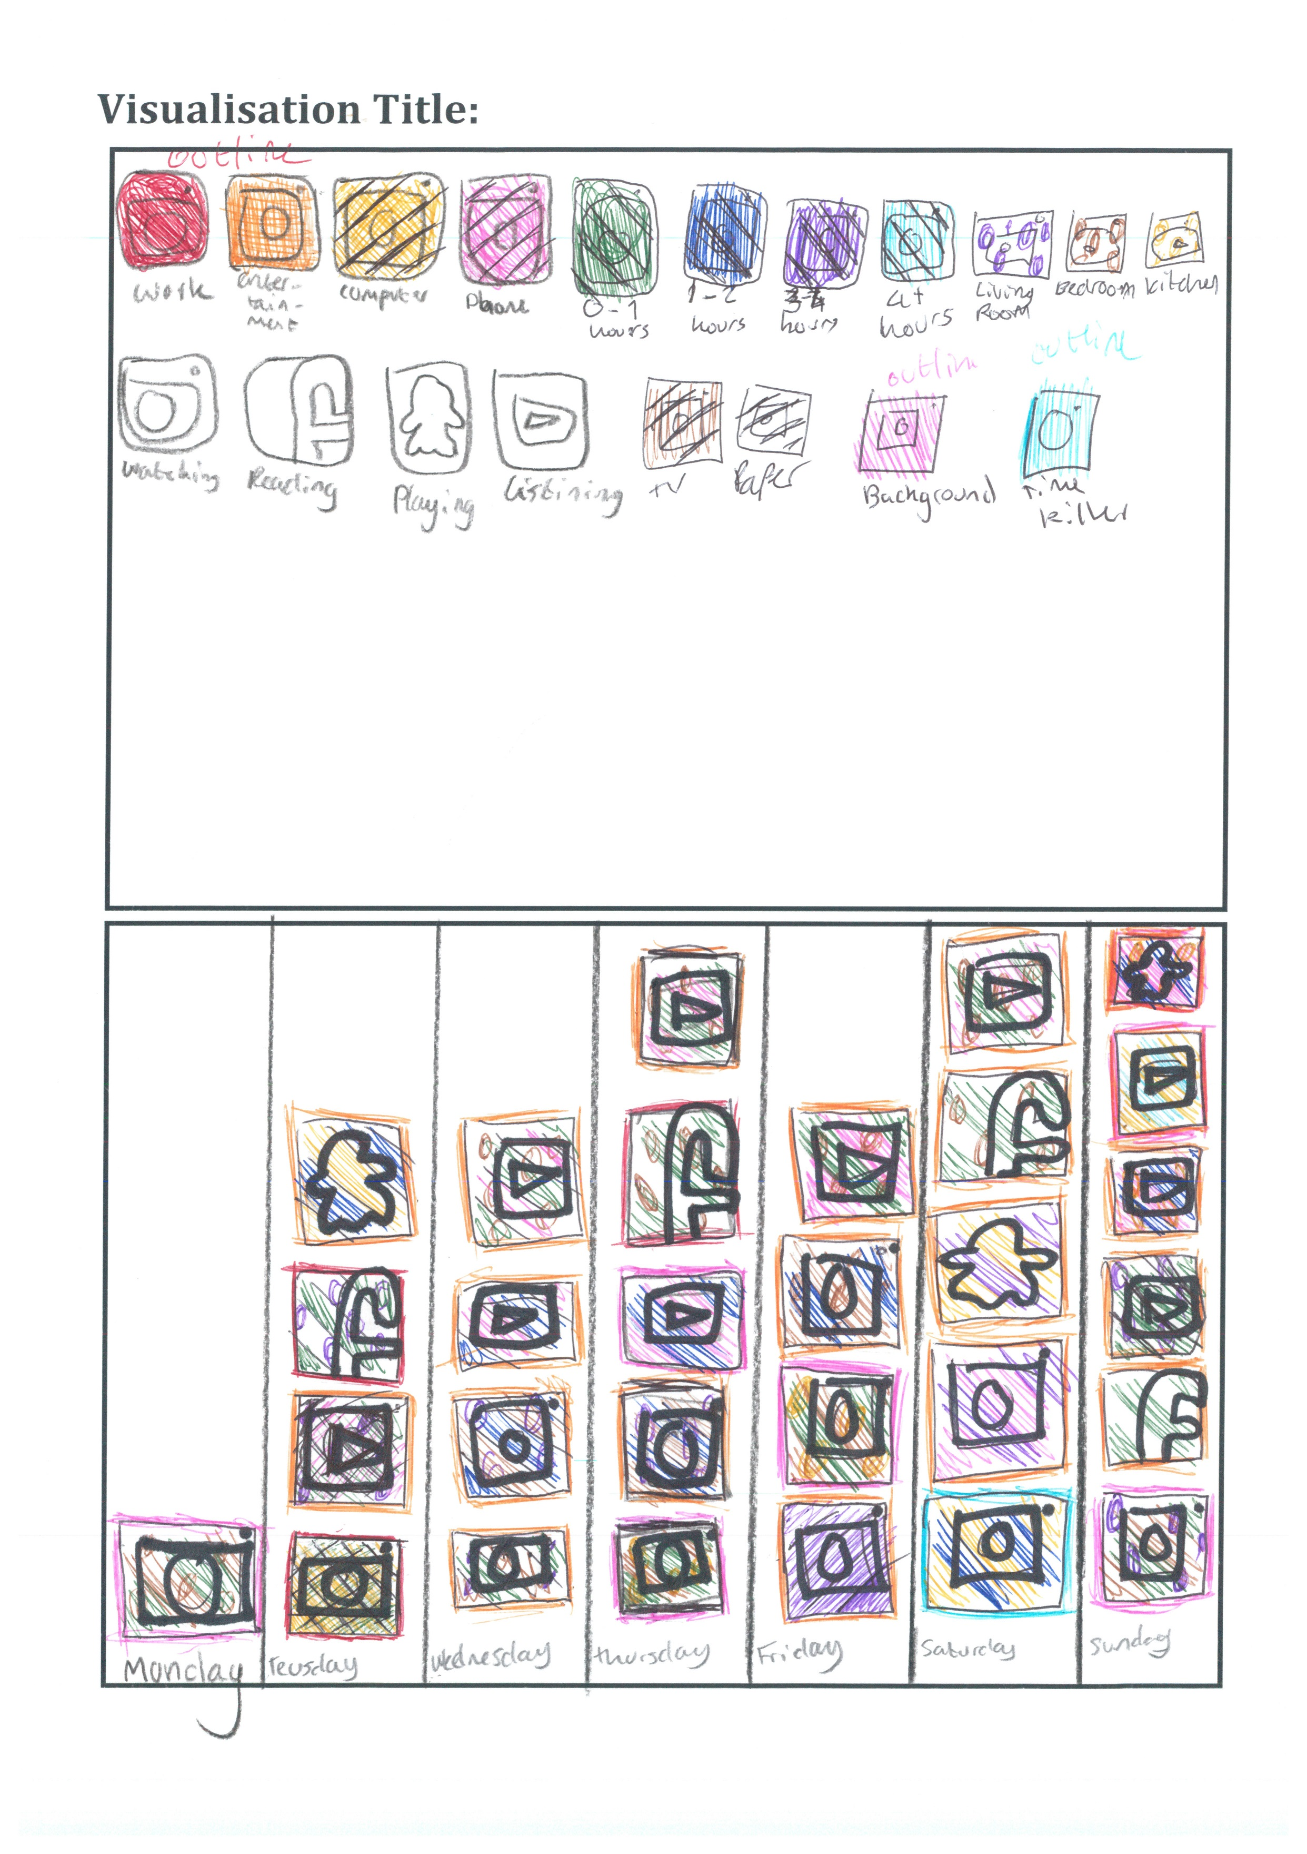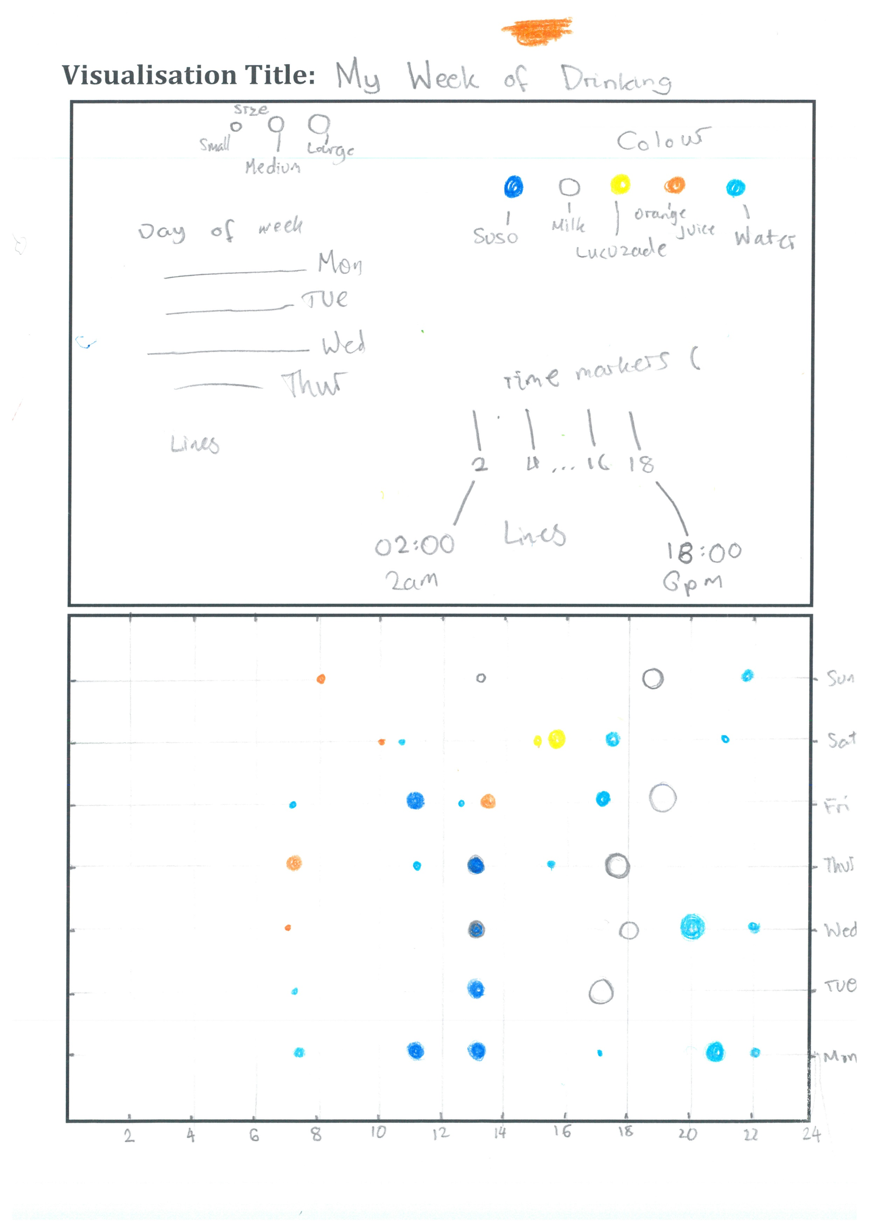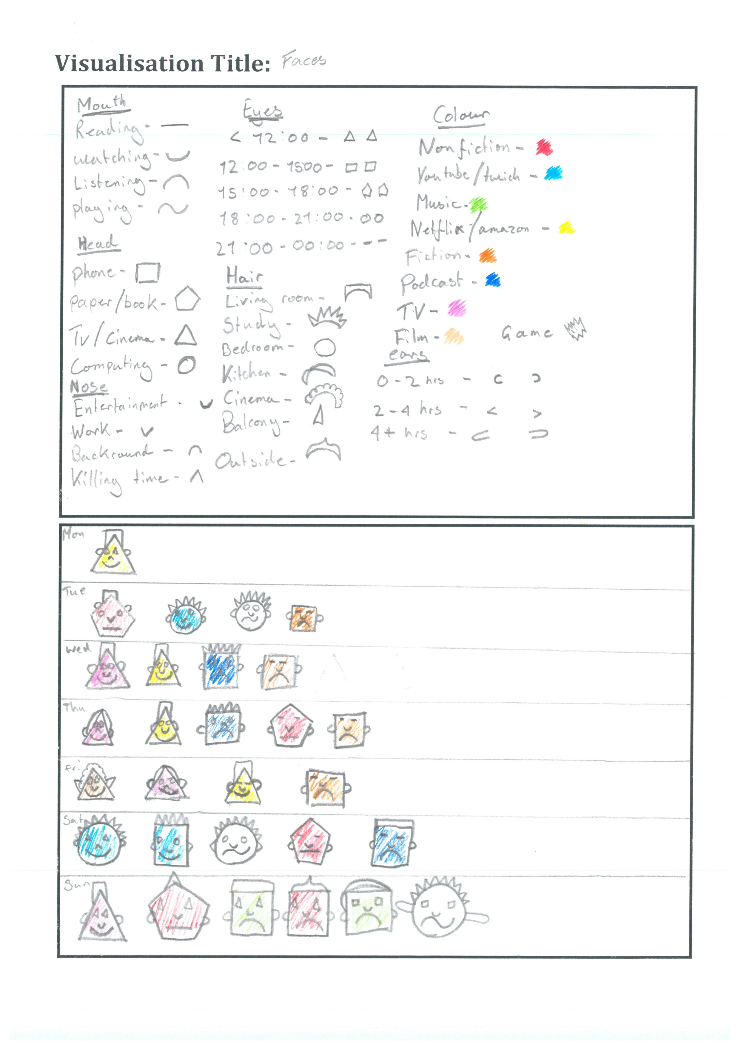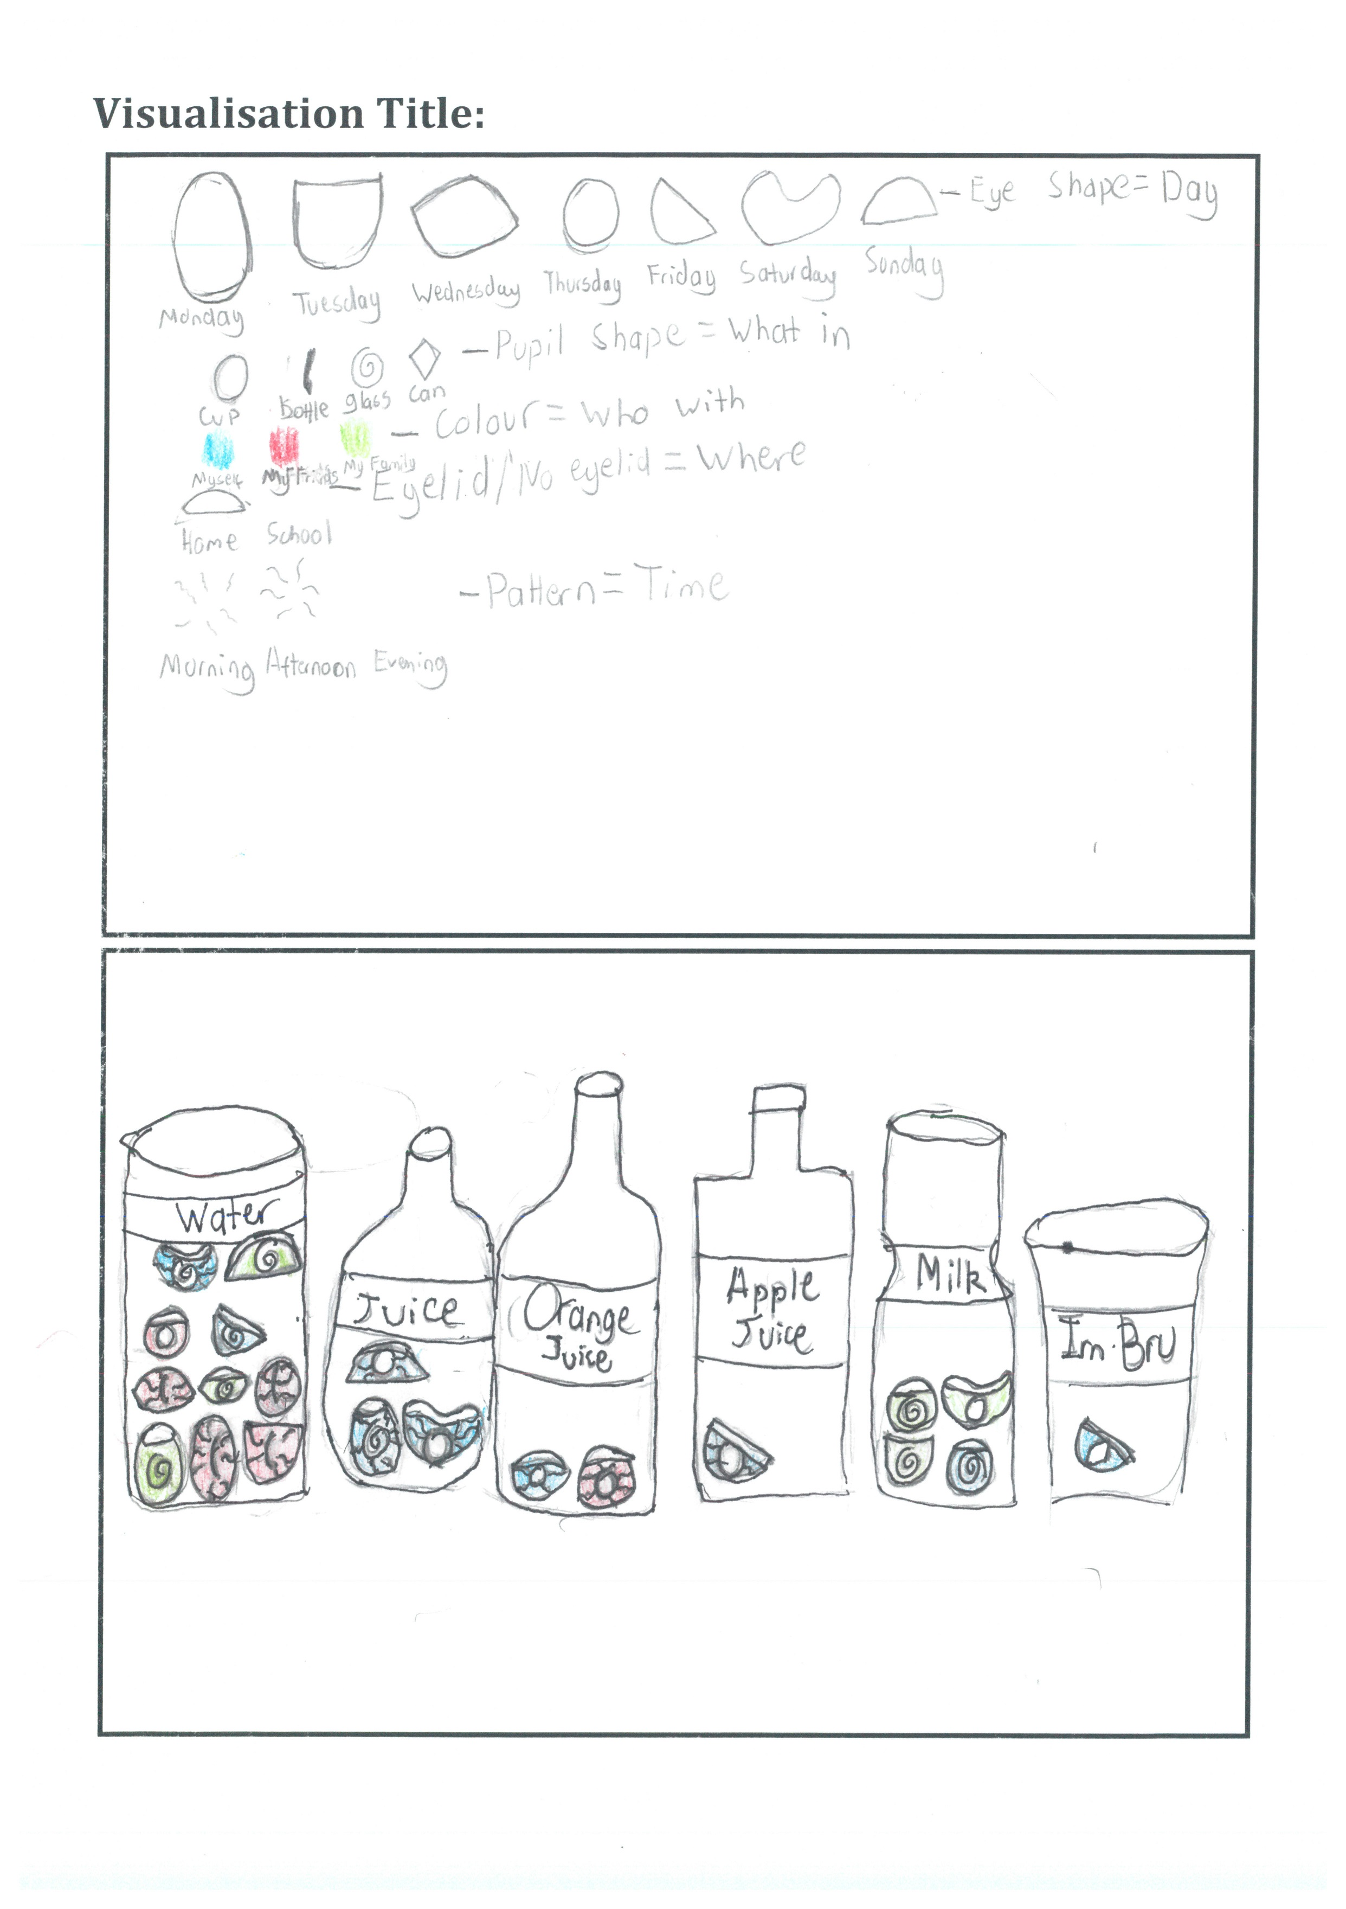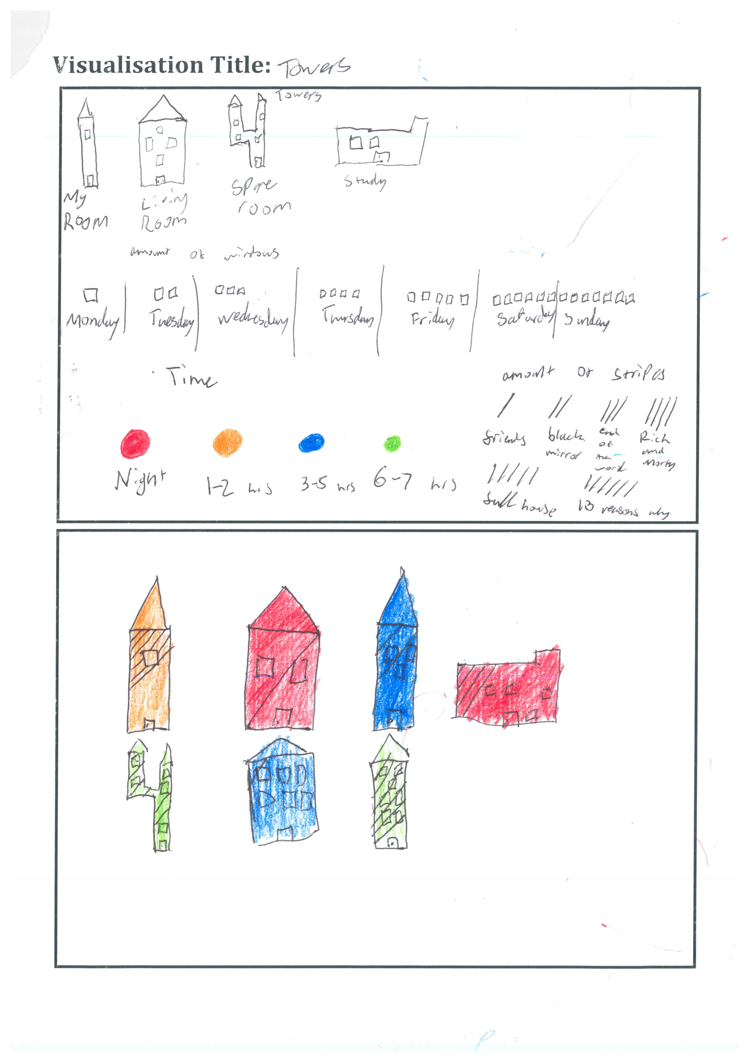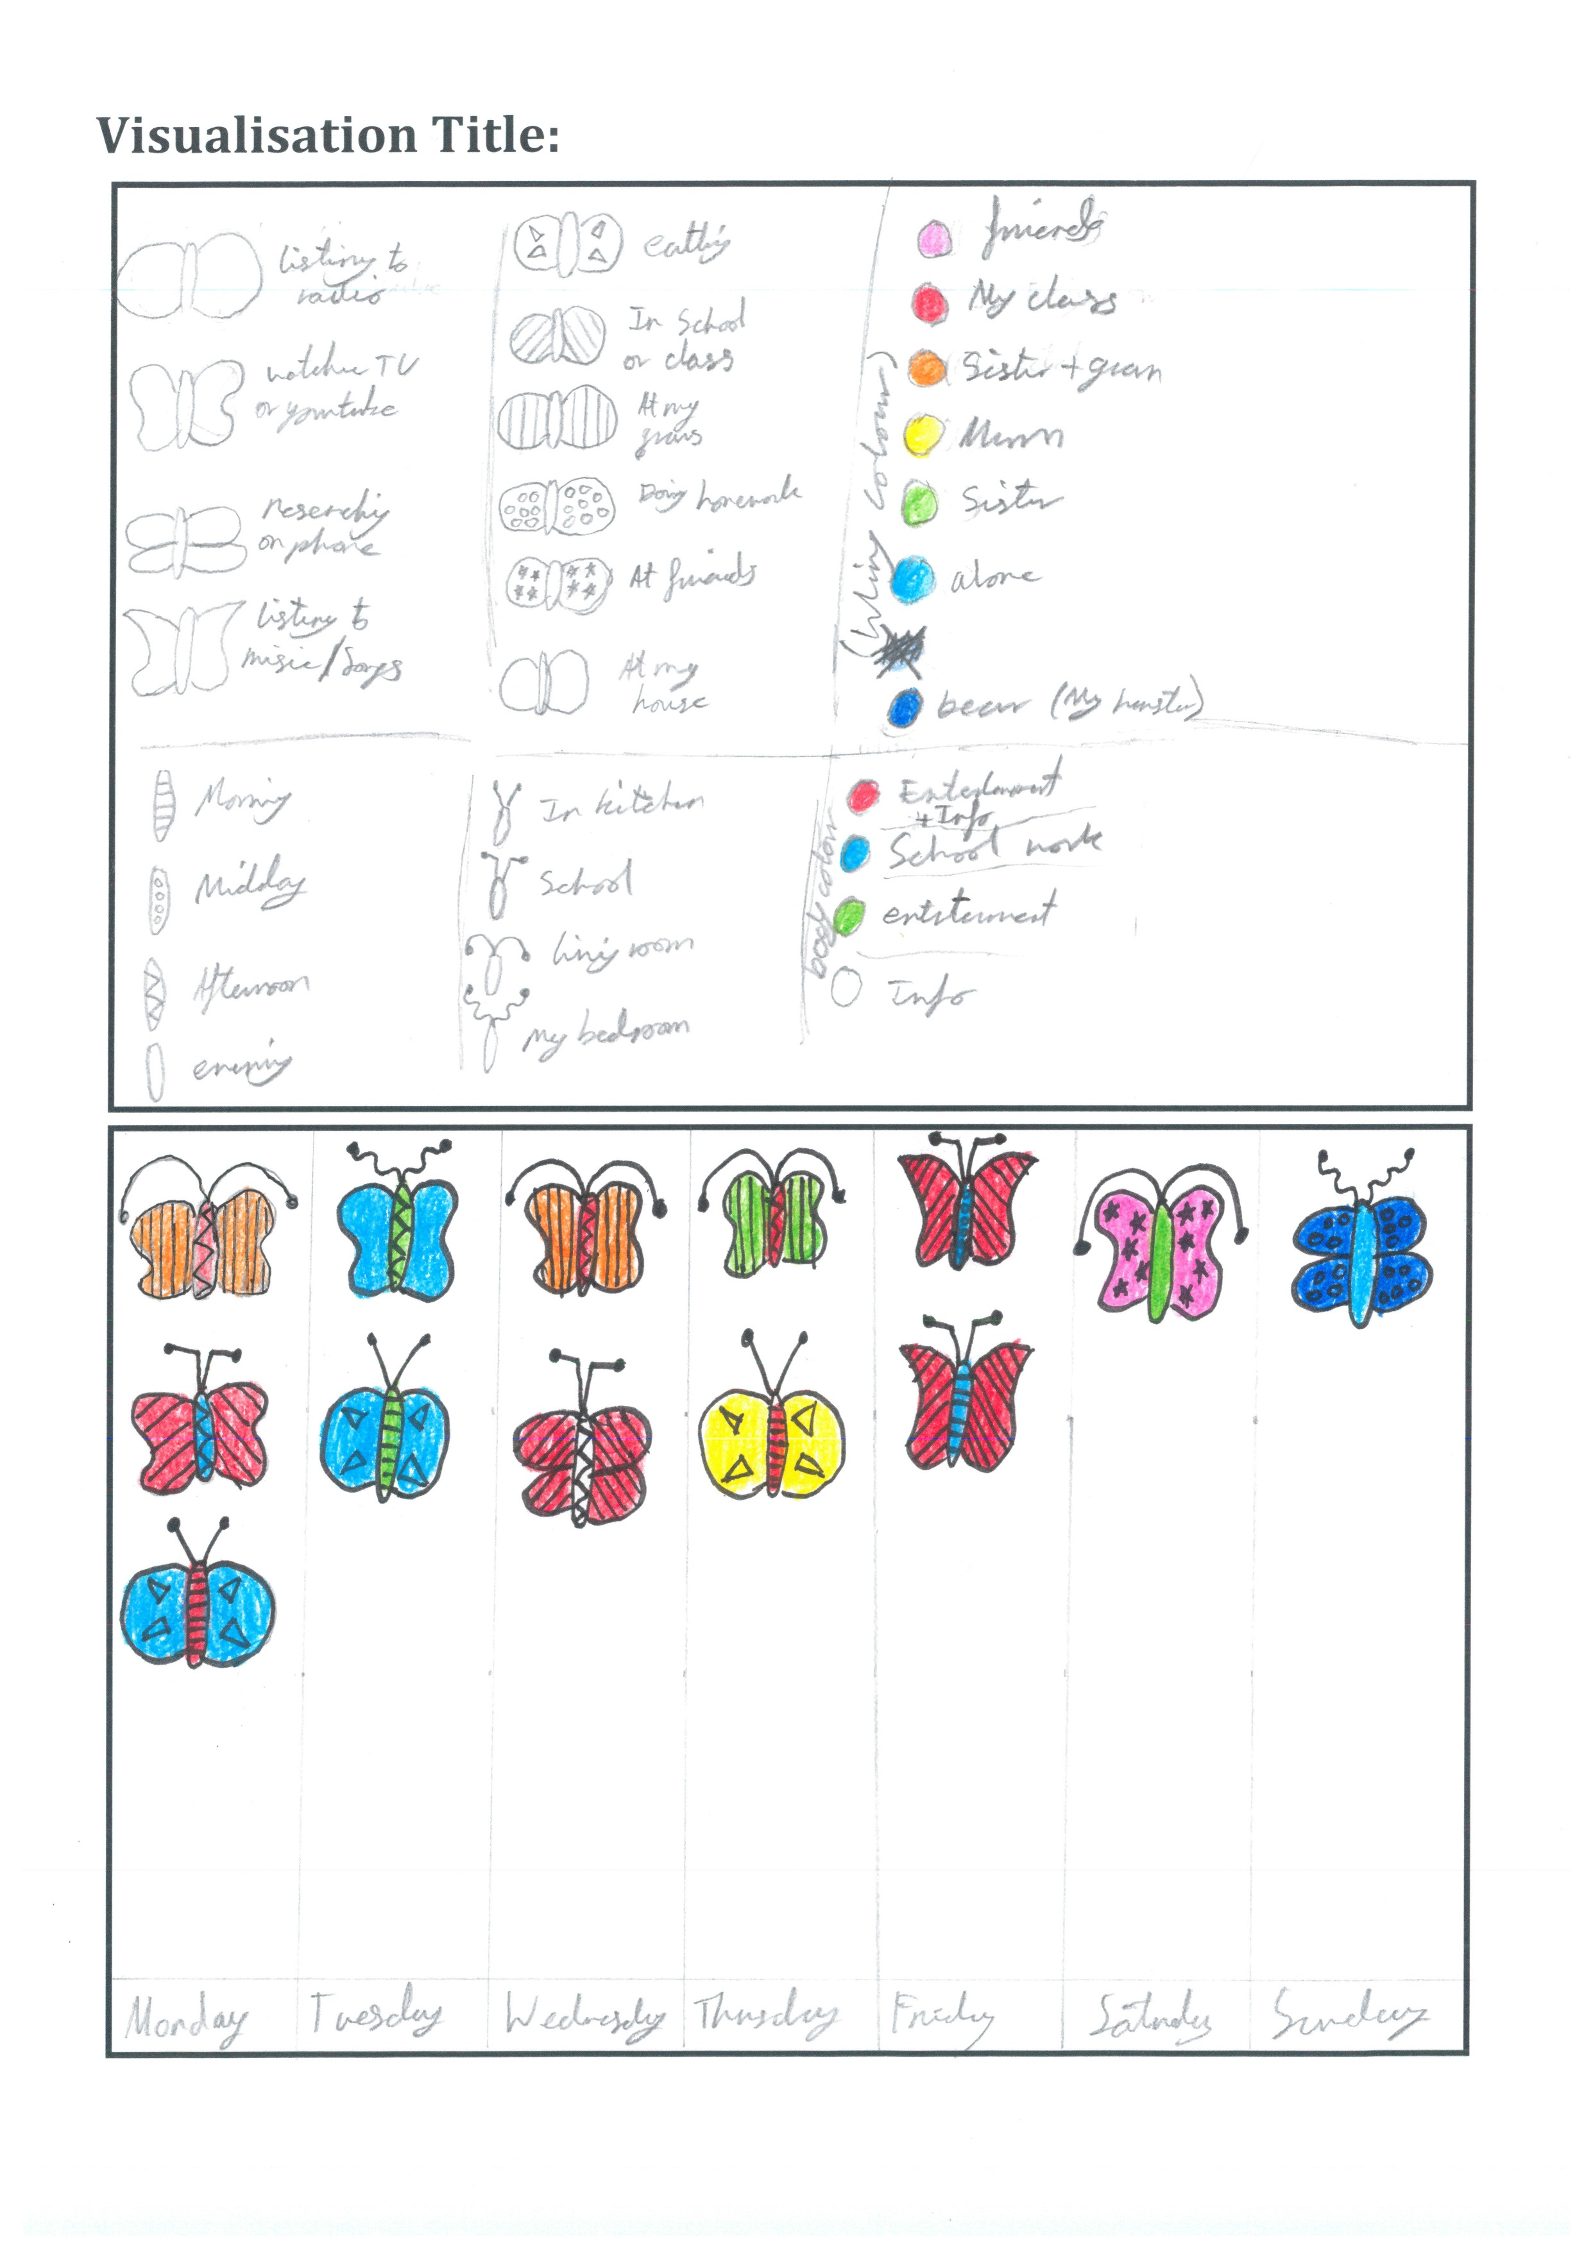

Appendix 5: Visualisation Template
Visualisation Title

