RESOURCE

Gapminder cards

Data vs What we think we know

Learning Level: First (P2-P4), Second (P5-P7)
Lesson Objectives:
Curricular Area: Social studies
Duration:
Materials: Paper, printer, pens

Introduction
This card sorting game helps us to highlight how we use data all the time to make decisions. It works best with a small group children or a family. The activity uses data and examples provided by Gapminder

Materials
- Printed Gapminder Countrycards or make your own. If making your own you can encourage children to create 16 cards with a country name and flag from this list
- Printed World Data Chart or view on screen
- Printed world map Worldmap or view on screen

Activity
- Give the country cards and the world map to the group.
- Ask the group to arrange the country cards according to the
development level of the countries. Part of this task is to consider what is meant by development level and what information you might need to decide on the development level. The older the group the more criteria likely to be considered when thinking about development level. The group can use the world map locate the countries and see if that helps them decide on the development level.
- After the group have decided how they want to arrange the cards ask them to talk through their approach. Does their way of sorting the countries reflect what they think the incomes of the countries are? Health? Development, something more more vague?
- Provide a copy of the World Data Chart. Explain the graph; each bubble is a country, the size of the bubble is the population, the colour the continent, the Y-axis is the life expectancy (i.e. health) and the X-axis is income per person.
- Find each of the countries on the cards on the data chart. Make sure they keep the order of the cards they previous arranged.
- Compare the sorted cards with the data chart, are there any differences? What surprises you most about the data chart?

Conclusion
This is a great task for comparing what we think we know with data and facts. Almost everyone discovers that they are not aware of some global facts. You can have fun checking your assumptions with the Gapminder Challenge (more suited to children 10+)
You can use Gapminder's Dollar Street to learn more about how people in different countries live. This can be a fun group or family discussion. Younger children will need help with reading but the discussion points are great for everyone.

Country Cards
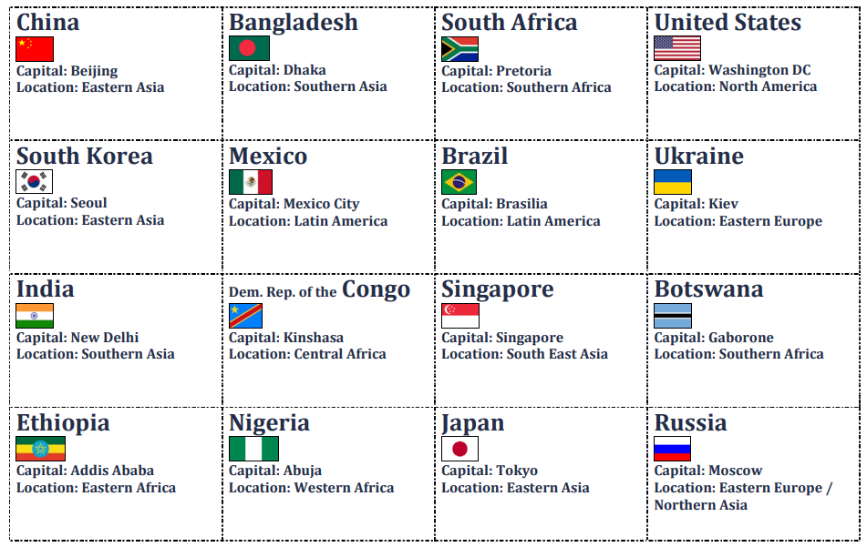

World Data Chart
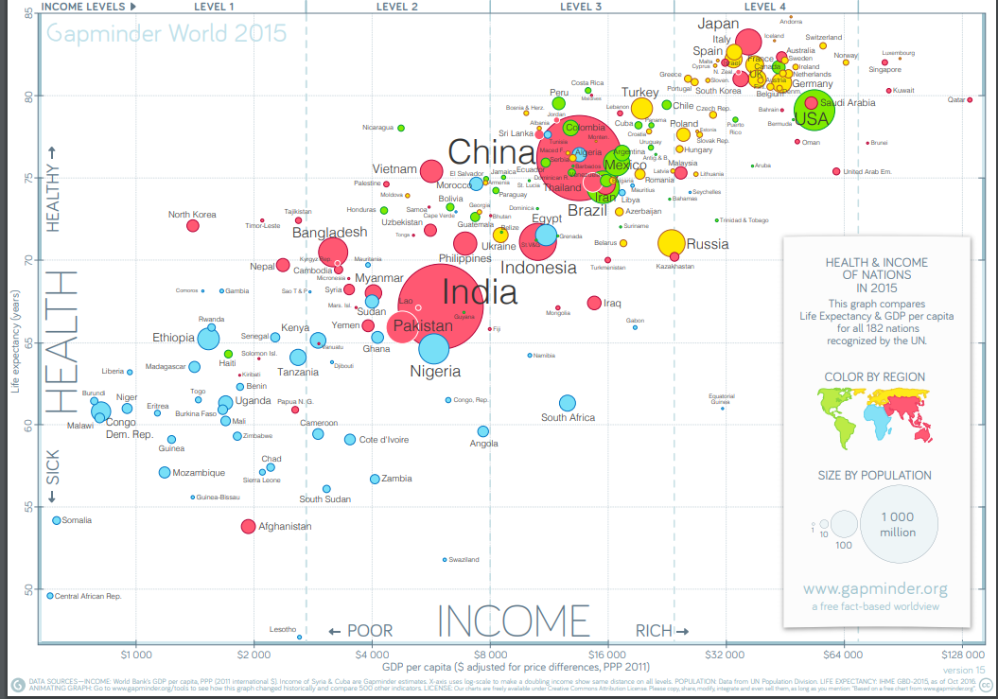

World Map

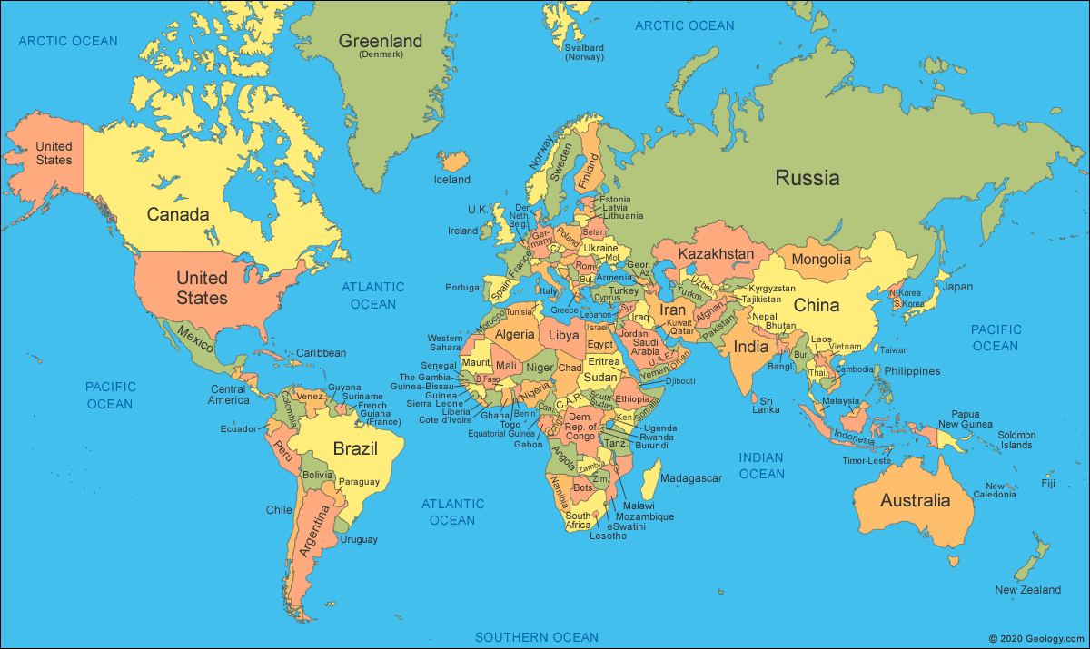

If you require this document in an alternative format, such as large print or a coloured background, please contact dataschools@ed.ac.uk.

