The University of Edinburgh is offering a free course about AI for secondary school teachers 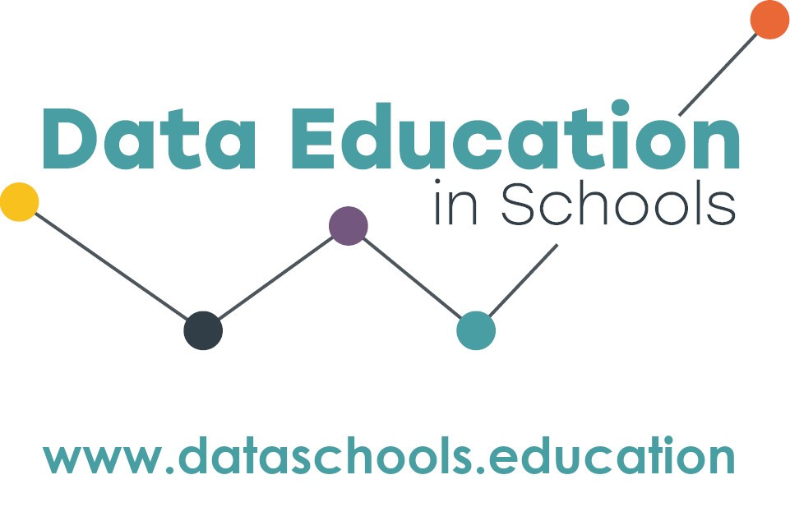.
As AI technology leaps forward, how will education change? How can teachers use new AI tools to support their learners and assist with their teaching preparation? This course, developed by experts in the field of AI data literacy and teaching, is an innovative and exciting opportunity for professional development.
“You will leave each session feeling motivated and enthusiastic to try new things”
“…a really supportive and positive experience” teachers who attended our previous courses

About the course
- There will be two full-day sessions on 29th April and 10th June 2024. All sessions will be taught face-to-face and held in central Edinburgh. You will need to attend them both.
- The course will be taught by Professor Judy Robertson, Dr Fiona McNeill, Kate Farrell and other members of the Data Education in Schools team.
- Topics covered will include a basic introduction to how AI works, hands-on activities to try AI tools, a guide to effective prompt writing, using GenAI for lesson planning and resource creation, developing learners’ AI literacy, supporting learners with GenAI tools, ethics and best practice including safeguarding.
- There are 15 places for teachers on the course.
- Cost for classroom cover will be provided.

How to apply
When applying to the course, teachers must commit to: attend all sessions; try out the course materials at their school; take part in research data collection activities; and share their knowledge with other teachers. Send the application form (below) to Judy.Robertson@ed.ac.uk by 17th April. You will be notified if you have a place by 24th April, at which time you will receive additional details.

Application Form | AI for secondary school teachers

Name:
School:
Subject taught:
Contact email:
Contact phone number:

Tell us about yourself, your school, and why you want to do this course (200 words) –

To be completed by the head teacher:
I understand that:
- The member of staff (named above) has applied for the course in AI at the University of Edinburgh
- If they are successful in getting a place they will be out of class on 29th April and 10th June 2024.
- Classroom cover will be funded by the University of Edinburgh and the school will be contacted about this funding once a place has been confirmed.
Name:
Date:
Form to be returned electronically to Judy.Robertson@ed.ac.uk by 5pm on 17th April 2024

