Zero-waste data physicalisation kit content possibilities

Bags
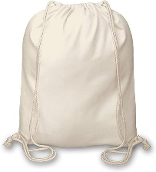
https://www.thecleverbaggers.co.uk/bags/drawstring-bags/cotton-drawstring-duffel-bag-40x45cm 20 for £50 inc delivery
20 at Amazon £24.90 https://www.amazon.co.uk/Shopping-Rucksacks-Drawstring-Friendly-Shoppers/dp/B07GSB6YWQ/ref=sr_1_26
HTV Vinyl to brand the bags https://www.amazon.co.uk/CELESTIQUE-Heat-Transfer-Vinyl-Material/dp/B0CFVVQ9RM/?th=1 £11.67 / £12.99 for 15ft

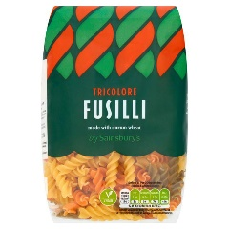
Tri-colour pasta
£0.75 per 500g bag (or shapes from Aldi/Lidl?)
https://groceries.asda.com/product/pasta-tubes-shells-spirals/asda-tricolore-fusilli/1000051196290

Beads
£4 per tub https://flyingtiger.com/en-gb/products/glass-beads-3032538
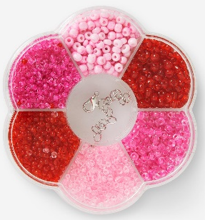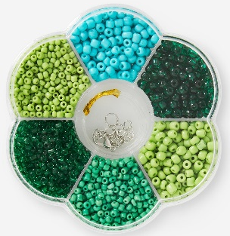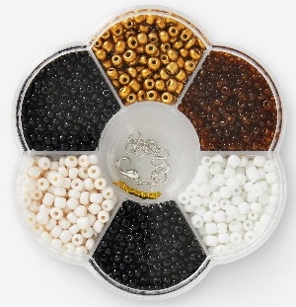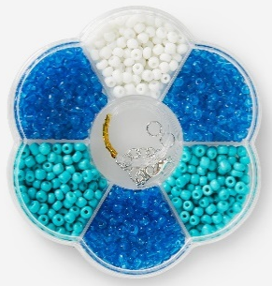
Hobbycraft 600 beads set £10 https://www.hobbycraft.co.uk/636673.html
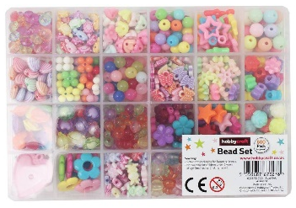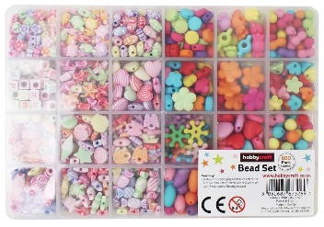
Ironing beads https://flyingtiger.com/en-gb/products/ironing-beads-3032565 2000 for £3 each type
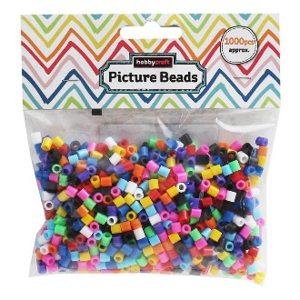
Or Hobbycraft £3 for 1000 https://www.hobbycraft.co.uk/bright-picture-beads-1000-pieces/6424531003.html
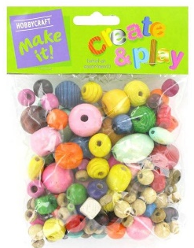
Wooden beads £1/£2 https://flyingtiger.com/en-gb/products/wooden-beads-3034693
or £4 at Hobbycraft
https://www.hobbycraft.co.uk/assorted-wooden-beads/5627091000.html
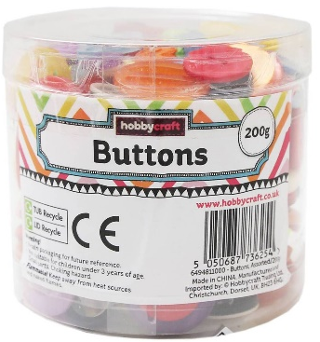

Buttons
https://www.hobbycraft.co.uk/assorted-jar-of-buttons-200g/6494811000.html 200g for £3

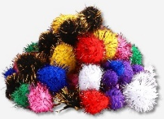
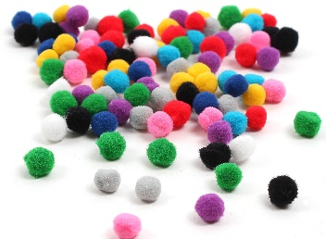
Pompoms
https://flyingtiger.com/en-gb/products/pom-poms-1450525 £1.50 for 20 large, 30 small

Hobbycraft 7mm 100 for £2.50 https://www.hobbycraft.co.uk/assorted-pom-poms-7mm-100-pack/6619661000.html

Or giant tub of 1000 assorted size and colour https://www.hobbycraft.co.uk/giant-tub-of-pom-poms-1000-pack/6446011000.html £8.50

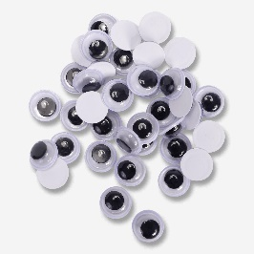
Googly eyes
https://flyingtiger.com/en-gb/products/wiggle-eyes-3006293 £1 for a pack of ~40
Same price at Hobbycraft https://www.hobbycraft.co.uk/googly-eyes-set-40-pieces/5716791000.html

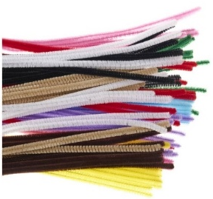
Pipe cleaners
£4 for 100 https://www.hobbycraft.co.uk/assorted-pipe-cleaners-100-pack/6619611000.html (good for bar graphs!) Multicolour / White / Black
Wooden sticks
£1 for 50 https://www.hobbycraft.co.uk/assorted-wooden-craft-sticks-50-pack/5630451000.html

String
Red/White and Green/White 100m £3.80 https://www.hobbycraft.co.uk/red-and-white-cotton-twine-100m/6532171000.html https://www.hobbycraft.co.uk/green-and-white-cotton-twine-100m/6532181000.html

Other Tools that might be required

Scissors
Glue
Felt Pens
Masking Tape (https://www.hobbycraft.co.uk/masking-tape-21mm-x-20m/6614441000.html £1 each)

More ideas

Snow / Rain graphs:
Bamboo cane
https://www.diy.com/departments/verve-bamboo-cane-120cm-pack-of-20/3663602423447_BQ.prd?alt=true 120cm pack of 20, £6.50
Cotton balls
Tissue paper
String
Needles

