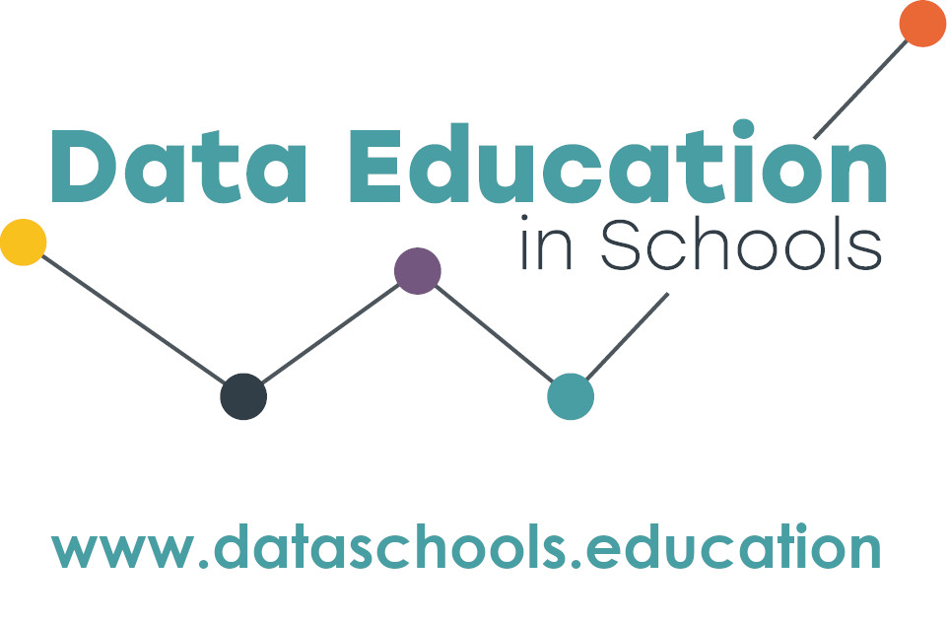

Data Education in Schools is offering a free course on data literacy in the primary classroom.
Data literacy is the ability to ask questions, collect, analyse, interpret, and communicate data. As technology makes it easier to collect vast amounts of data, the skills to use data to solve problems fairly will become even more important. This course, developed by experts in the field of digital and data literacy and primary teaching, is an innovative and exciting opportunity for professional development.
“This course has given me the confidence and desire to present the data work that I do with children in a more engaging way”
“…a really supportive and positive experience” Primary teachers who attended the course in 2022/23

About the course
- There will be four full-day sessions on Wednesday 11th September 2024, 13th November, 26th February 2025, and 28th May 2025. All sessions will be taught face-to-face and held in central Edinburgh. You will need to attend them all.
- The course will be taught by Professor Judy Robertson and Dr Jasmeen Kanwal and Kate Farrell and will other members of the Data Education in Schools team.
- Topics covered will include:
  - Exploring how data is used to solve real life problems. From election dashboards in the newspaper, to the smart meters in your cupboard, to the Fitbit in your pocket: data displays are everywhere. We’ll consider how data be used ethically to make decisions and improve our lives.
  - The data cycle. We’ll learn about the Problem Plan Data Analysis Communication (PPDAC) cycle for data problem solving, and how you can teach this process to your learners in real life projects, both with and without technology.
  - Links, strategies and big questions: We’ll explore how to develop strategies to ensure that every child participates meaningfully in opportunities to develop their data literacy. We will identify digital and non-digital pedagogical approaches to teaching data literacy, and explore how this may enrich the ways in which all learners are included in class activities. This is important to our commitment to close the attainment gap.
- There are 15 places for teachers on the course. All primary school teachers in the South East of Scotland (City of Edinburgh, Fife, Borders, East Lothian, Midlothian and West Lothian) may submit an application for a place. Preference will be given to teachers in schools that have not previously participated in this course.
- Cost for classroom cover will be provided.

How to apply
When applying to the course, teachers must commit to: attend all sessions; try out the course materials at their school; take part in research data collection activities; and share their knowledge with other teachers. Send the application form (below) to Jasmeen.Kanwal@ed.ac.uk by Friday 14th June. You will be notified if you have a place by during the first week of term, at which time you will receive additional details.

Application Form | Data Literacy for Primary School Teachers in South East Scotland

Name:
School:
Year group taught:
Contact email:
Contact phone number:

Tell us about yourself, your school, and why you want to do this course (200 words) –

To be completed by the head teacher:
I understand that:
- The member of staff (named above) has applied for the course in Data Literacy at Moray House School of Education and Sport.
- If they are successful in getting a place they will be out of class on Wednesday 11th September 2024, 13th November, 26th February 2025, and 28th May 2025.
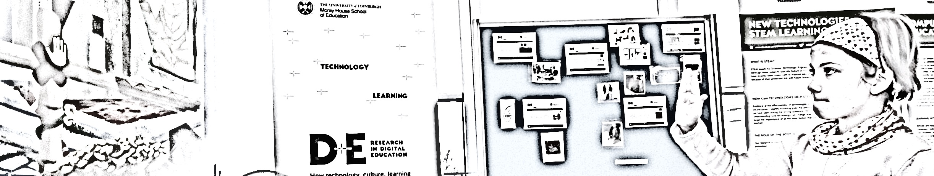
- Classroom cover will be funded through the Data Education in Schools programme and the school will be contacted about this funding once a place has been confirmed.
Name:
Date:
Form to be returned electronically to Jasmeen.Kanwal@ed.ac.uk by Friday 14th June 2024

