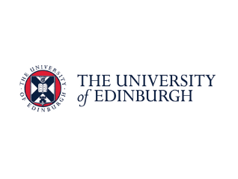
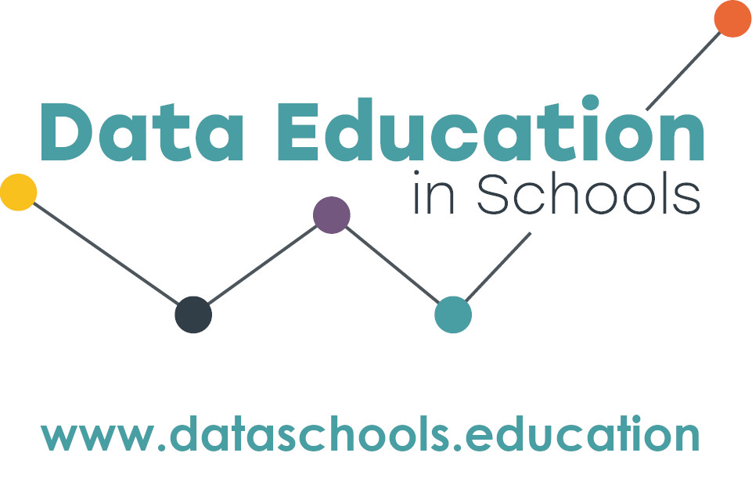

Moray House School of Education and Sport is offering a free course on Data Science in the Secondary classroom.
Data science is the ability to ask questions, collect, analyse, interpret, communicate about data. As technology makes it easier to collect vast amounts of data, the skills to use data to solve problems fairly will become even more important. This course, developed by experts in the field of digital and data literacy and secondary teaching is an innovative and exciting opportunity for professional development.

About the course
- There will be four full-day sessions Thursday 5th September 2024, Wednesday 2nd October, Tuesday 5th November, and Monday 2nd December 2024. The sessions are face to face (following feedback by teachers on previous workshops) but it may be possible to join virtually if required. You will need to attend all of the sessions.
- The course will be taught by Dr Jasmeen Kanwal, Kate Farrell and John Bell (Effini) and will include collaboration with data scientists, colleagues in industry, and educational experts.
- Topics covered will include:
  - Exploring how data is used to solve real life problems. From coronavirus dashboards in the newspaper, to the smart meters in your cupboard, to the Fitbit in your pocket: data displays are everywhere. We’ll consider how data be used ethically to make decisions and improve our lives.
  - Teaching strategies and core concepts: We’ll explore how to develop strategies to ensure that every learner participates meaningfully in opportunities to develop their data literacy. We will identify digital and non-digital pedagogical approaches to teaching data science, and explore how this may enrich the ways in which all learners are included in class activities. This is important to our commitment to close the attainment gap. We will also look at ways to engage learners in data for social good projects and activism, using data to benefit their schools and communities.
  - Data Science within BGE: We will look at projects, resources and ideas for teaching data within different curricular areas of Broad General Education.
  - NPA Data Science: We will cover the core concepts in the National Progression Award in Data Science (Levels 4-6)
- There are 15 places for teachers on the course. Secondary school teachers in the South East of Scotland (City of Edinburgh, Fife, Borders, East Lothian, Midlothian and West Lothian) may submit an application for a place. Preference will be given to teachers who will be delivering the NPA in 2024-25 or who work in schools who are working to close the attainment gap, or to improve their technology provision.
- Cost for classroom cover will be provided.

How to apply
When applying to the course, teachers must commit to: attend all sessions; try out the course materials at their school; take part in research data collection activities; and share their knowledge with other teachers. Send the application form (below) to Jasmeen.Kanwal@ed.ac.uk by Friday 14th June 2024. You will be notified if you have a place during the last week of term, at which time you will receive additional details.

Application Form | Data Science for Secondary School Teachers in South East Scotland

Name:
School:
Local authority:
Subject(s) taught:
Contact email:
Contact phone number:

Tell us about yourself, your school, and why you want to do this course (~200 words):

To be completed by the head teacher:
I understand that:
- The member of staff (named above) has applied for the course in Data Science at Moray House School of Education and Sport.
- If they are successful in getting a place they will be out of class on Thursday 5th September 2024, Wednesday 2nd October, Tuesday 5th November, and Monday 2nd December 2024.
- Classroom cover will be funded.
Name:
Contact email:
Date:
Form to be returned electronically to Jasmeen.Kanwal@ed.ac.uk by Friday 14th June 2024.

