**Midge Project – Recognising Patterns in Numerical Data**

**Introduction**

Train a machine learning model to recognise patterns in numerical data and help classify midges as **biting** vs **non-biting**.

BITING

You will need:

* ML for Kids
* CSV files: **biting.csv** and **non-biting.csv**
* This project uses a technology called ‘machine learning’. Machine learning systems are trained using a large amount of data.
* This project does not require you to create an account or log in. For this project, the examples you use to make the model are only stored temporarily in your browser (only on your machine).

**Set Up the Project**

Go to [machinelearningforkids.co.uk](https://machinelearningforkids.co.uk/#!/login) in a web browser.

Click on **Get started**.

Click on **Try it now**.

Click on **Projects** in the menu bar at the top.

Click on the **+ Add a new project** button.

Name your project Midge Project – Recognising Numbers and set it to learn to recognise **numbers**, and store data in your web browser.

Before you click on **Create** you will have to add values to recognise.

Click **ADD VALUE** button

For Value 1 type “legs’ and for Type of value select “number”.

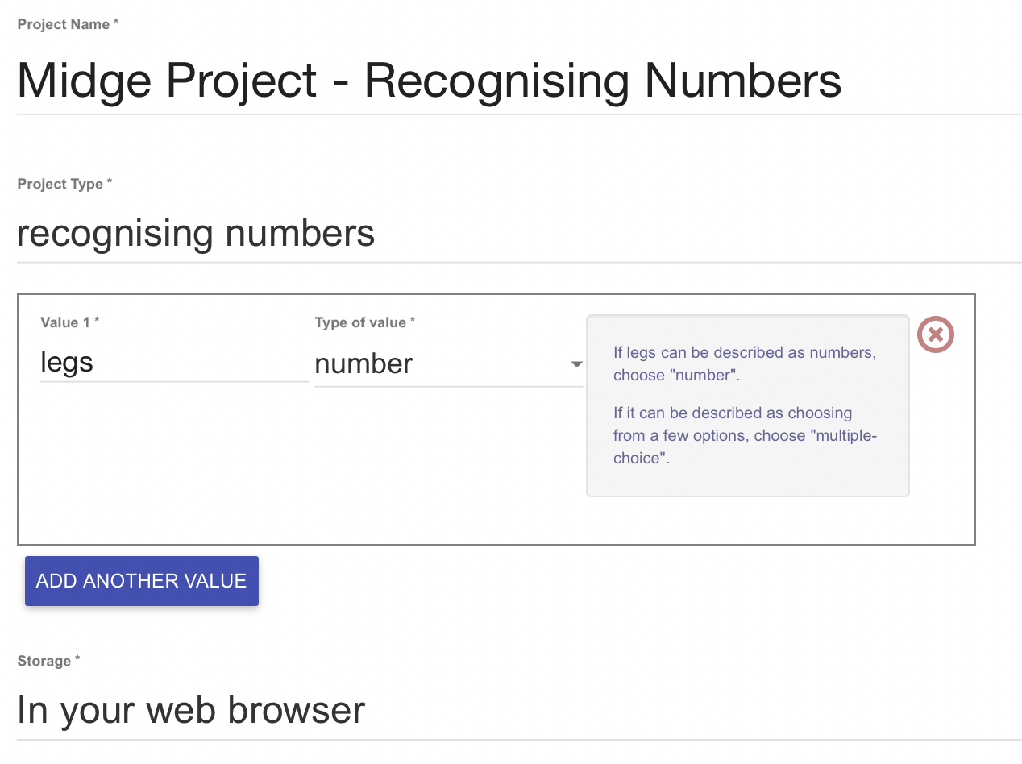

Click ADD ANOTHER VALUE and repeat the process for Values 2 to 10.

NOTE: Pay close attention to the value names. If you are using the supplied .csv files you **must** type them exactly as you see them here with correct spellings, lowercase and underscore.

Once you are ready, click **Create**.

Click on your project

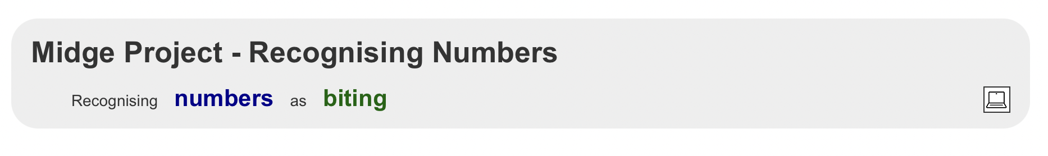Click Train

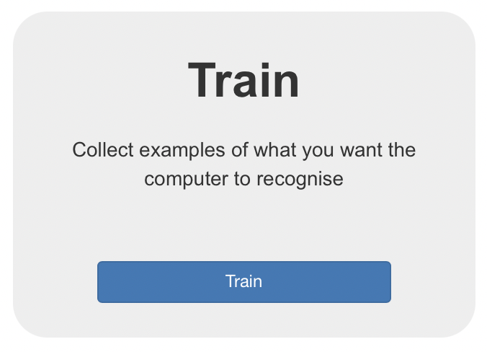

Click +Add new label and type “biting”

Click Add file and locate the file biting.csv

If you have named your fields accurately the model will import 16 sets of midge number data.

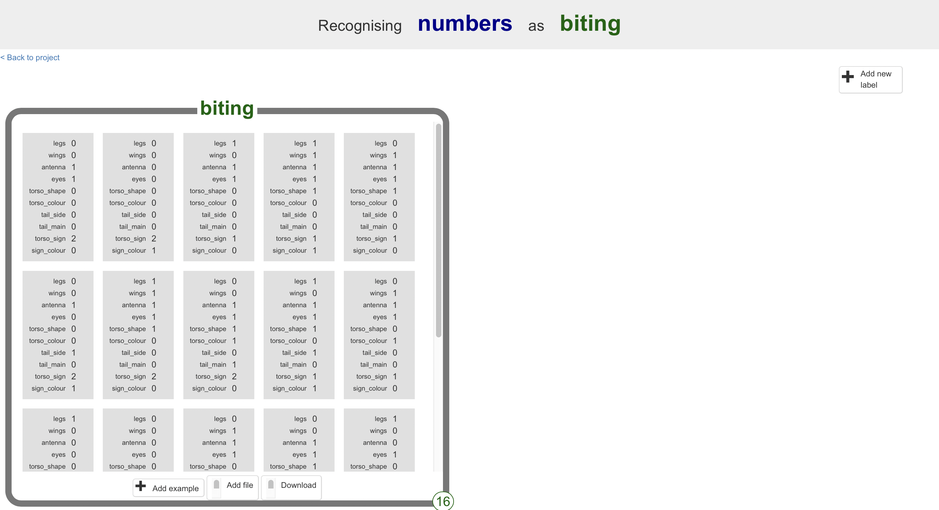

Repeat the process for non-biting midge data.

Click +Add new label and type “non_biting”

Click Add file and locate the file non-biting.csv

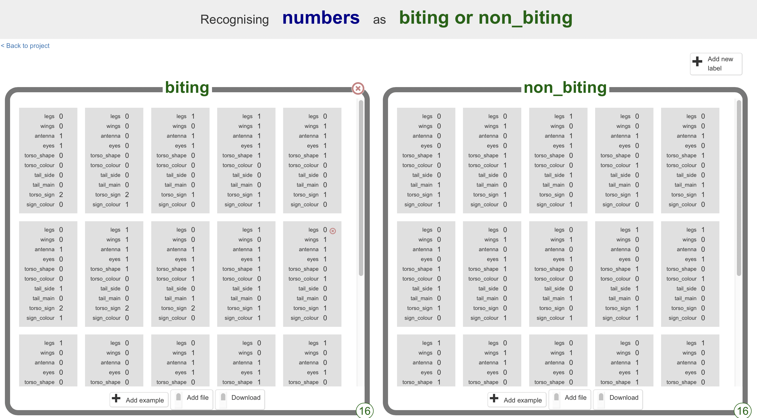

Click <Back to project

Click Learn & Test

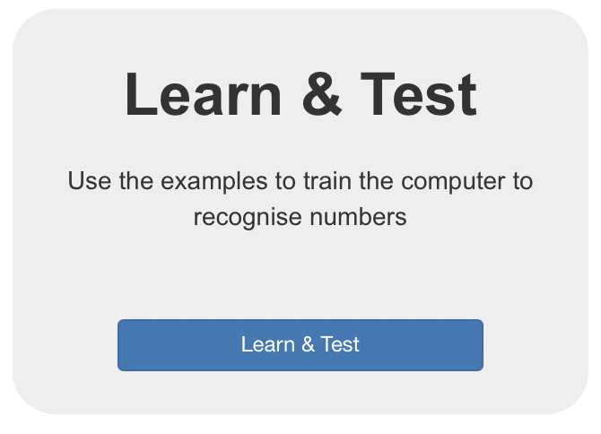

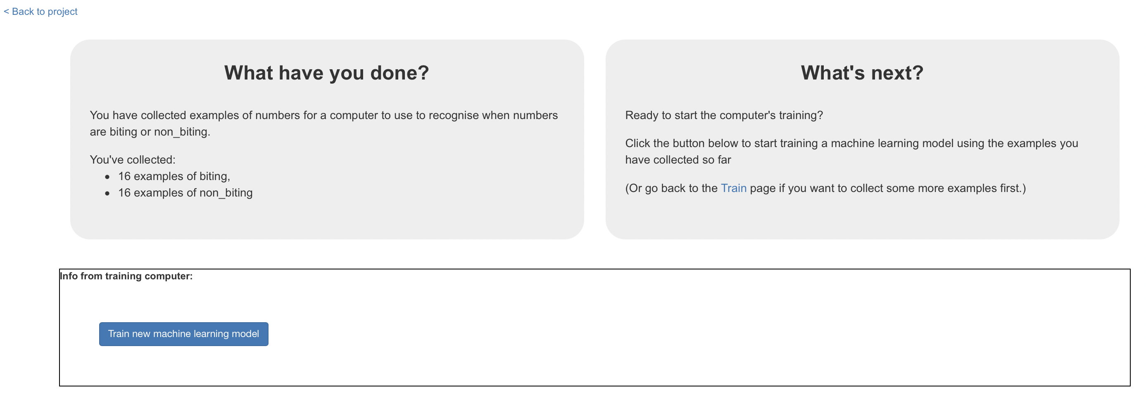

Click Train new machine learning model

Once the model has been trained you can test it by entering some values.

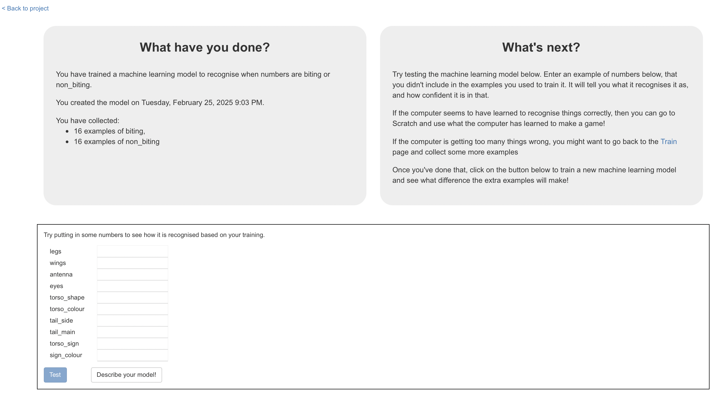

Remember our Decision tree from Lesson 1

Midges with torso_sign = tear should be biting midge.

To test your model, try entering “2” for torso_sign and make all other values “0”.

(Remember 0 = heart, 1 = star, 2 = tear)

Press Test

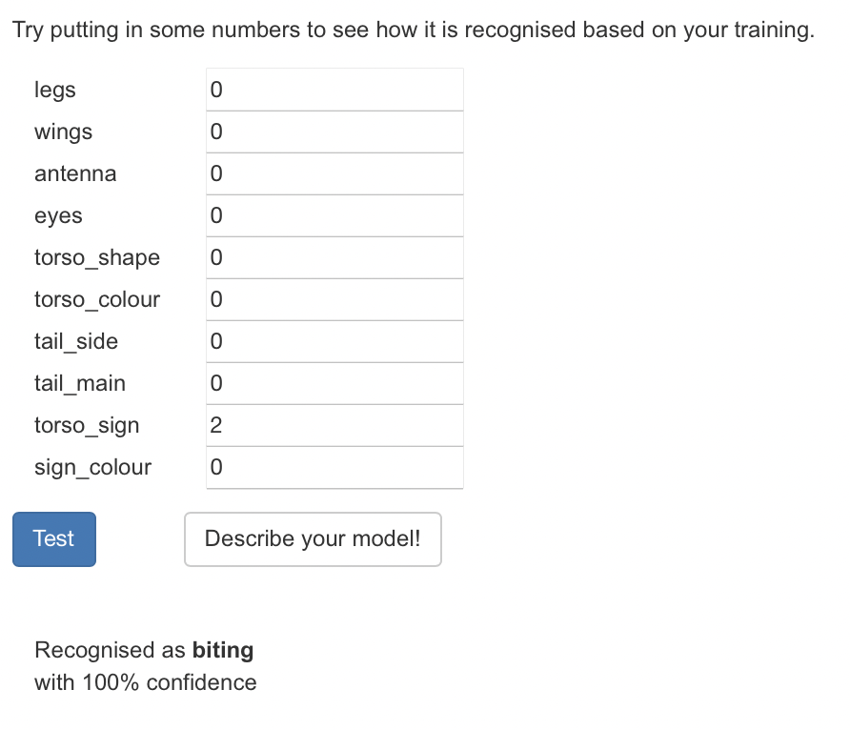

Your model should recognise **biting** with 100% confidence.

When you are ready click “Describe your model!”

You will be presented with a decision tree representing your model!

Take your time to understand what each node on the decision tree means.

Now try out your machine learning model to see how it uses the decision tree to make predictions.